Our Vote – Our Values
Complete Lesson Plan

Terms and Definitions Related to Voting (taken from the U.S. Election Assistance Commission except as noted)
- Absentee Voter – A voter who uses an absentee ballot to vote
- Accessibility – Measurable characteristics that indicate the degree to which a system is available to, and usable by, individuals with disabilities. The most common disabilities include those associated with vision, hearing and mobility, as well as cognitive disabilities.
- Active Registered Voter – A voter whose record is current with the appropriate election authority and is eligible to vote.
- Automatic Voter Registration (AVR) – Under an automatic voter registration system, eligible voters are automatically registered to vote whenever they interact with government agencies (e.g., departments of motor vehicles).
- Board of Registrars – A group of individuals appointed, usually by local authorities and charged with control of elections and voting.
- Cancellation of Registration – The act of removing a voter from a voter registration list.
- Centralized Voter Registration Database (CVR) – A single, uniform, official, computerized statewide database of registered voters.
- Close of Registration – The last day that a citizen can register to vote or update their voter registration before an election.
- Conditional Voter Registration – Some states use this term to define the action of an individual registering and casting a provisional ballot after the statutory deadline, but whose eligibility or registration status could not be confirmed when they present themselves to vote.
- Constitution – The basic principles and laws of a nation, state, or social group that determine the powers and duties of the government and guarantee certain rights to the people in it.
- Disqualification – The action of disqualifying a candidate or voter from participating in an electoral process.
- Electronic Poll Book – Device that partially automates the process of checking in voters, assigning them the correct ballot style, and marking voters who have been issued a ballot. May be used in place of a traditional paper poll book. E-poll books can be stand alone at the precinct with a separate copy of the registration list or can be networked into a central voter registration system where they can check and update voter records in real time.
- Eligible Citizens – The universe of all voters who, if they cast a ballot, would have the legal right to have eligible contests on that ballot tabulated. This would include those who do not appear in the list of eligible voters because they live in a same-day registration or no registration state and did not or could not register ahead of time.
- Eligible to Vote – A person who meets the requirements set forth in a political subdivision for being able to vote.
- Eligible Voters – The universe of all voters who, if they cast a ballot, would have the legal right to have eligible contests on that ballot tabulated. This would include those who do not appear in the list of eligible voters because they live in a same-day registration or no registration state and did not or could not register ahead of time.
- Fixed Resident – When a person lawfully and habitually uses a living quarters a majority of the week, it is considered a fixed residence for voting purposes, and the voter is referred to as a fixed resident.
- Forms of Identification – Means of proving a person's identity, especially in the form of official papers. Common examples include Driver's Licenses, Passports and other Government issued documents.
- Gerrymandering – the practice of drawing voting district boundaries with the intent to influence the outcome of elections in order to favor a particular political party.
- List of Registered Voters – A list of the individuals that have registered on an electoral roll where a voter resides, as a prerequisite for being entitled to vote.
- Literacy Tests – once used as a practice to test the literacy of citizens who appeared to vote, the practice was originally designed to ensure that citizens understood the ballots they were casting (could also be accompanied by questions about the state or federal Constitution). The act became so skewed towards eliminating Black, Native American, and Latino voters that the Voting Rights Act of 1965 (followed by the US Supreme Court) restricted the practice.
- Motor Voter – This act, commonly known as the “Motor Voter Law,” requires that states offer the opportunity to register to vote at their motor vehicle licensing offices (known as the DMV in many states). The law also requires states to offer voter registration at offices that provide public assistance or state-funded programs primarily engaged in providing services to persons with disabilities, and armed services recruitment offices. NVRA also provides guidelines on registration list maintenance and sets limits on how voters can be removed from the rolls.
- Online Registration – Online voter registration follows essentially the same process as a traditional paper-based process, by which new voters fill out a paper form that is submitted to election officials, but instead of filling out a paper application, the voter fills out a form via an Internet site, and that paperless form is submitted electronically to election officials. In most states the application is reviewed electronically. If the request is confirmed to be valid, the new registration is added to the state’s voter registration list.
- Pre-election period – one of the stages of the election cycle, this process includes the registration of eligible voters, training of election workers, planning of the election, and education of the voter.
- Poll Book – An official register of electors entitled to vote at an election, used to verify and check in voters prior to issuing them a ballot.
- Poll Tax – an antiquated requirement that a voter pay a fee in order to vote in elections, which often limited voting for poor citizens (eliminated federally by the 24th Amendment and the Voting Rights Act of 1965).
- Provisional Voting – The act of casting a ballot by a voter who was not on the list of eligible voters, whose information was incomplete or not accurate, or who had already received a ballot in the mail and was allowed to vote. Provisional ballots are usually kept separate from the other ballots until an election official can determine if the voter is eligible to vote. These ballots are sometimes called fail-safe votes.
- Qualification – A requirement, such as being a registered voter, that is necessary in order for a voter, candidate, or election process to be acceptable for a specific purpose.
- Register to Vote – To complete a form with information to be added to an electoral roll for the jurisdiction where a voter resides, as a prerequisite for being entitled to vote.
- Registration Deadline – The last day to complete the documents to become a registered voter to participate in a specific election or election process.
- Residency Requirement – The rules that govern if an individual is entitled to become a candidate or vote, based on where they live, and how long they have lived there.
- Time Off for Voting – Almost every state prohibits employers from disciplining or firing an employee who takes time off work to vote. Some state laws require employers to give their employees a specific amount of time off to cast their ballots. In some states, this time off must be paid; in others, it may be unpaid.
- U.S. Election Assistance Commission (EAC) – The Election Assistance Commission was created by the Help America Vote Act (HAVA) to assist the states regarding HAVA compliance and to distribute HAVA funds to the states. The EAC is also charged with creating voting system guidelines and operating the federal government’s first voting system certification program. The EAC is also responsible for maintaining the National Voter Registration form, conducting research, and administering a national clearinghouse on elections that includes shared practices, information for voters, and other resources to improve elections.
- Vote – A valid mark on an official ballot indicating the voter's preference for a particular candidate or ballot question.
- Voter Registration Drive – An effort by a government authority, political party, or other entity to register to vote persons otherwise entitled to vote. Participants in a voter registration drive distribute voter registration forms, provide assistance in completing them, and return the forms to elections offices.
- Voting Restrictions – A law or set of laws that make it more difficult for people to vote.
- Voting Right – The set of laws that protect a citizen’s ability to participate in public elections.

Case Study One: Same Day Voter Registration Lesson Plan
This lesson plan outlines a multi-pronged approach to discussing the debates surrounding Same Day Voter Registration with students. Teachers may elect to use the material in the sequence provided or, depending on their timeframe, use just one or two elements to fit into their existing lesson plans.
This lesson plan addresses WV College and Career-Readiness Standards for Social Studies (2520.4) wvccr_socialstudies_6-12-revised.pdf with the following components:
- Civics – by specifically covering the history and practice of voter registration, this lesson plan is directly on point to help prepare “students to be informed, active and effective citizens who accept their responsibilities, understand their privileges and rights and participate actively in society and government.” Grades 6-8 will be able to appropriately place voter registration history within the context of the US Civil Rights movement. Grades 7-12 will be able to analyze the rights and responsibilities of citizens as they relate to voting, and the ways in which voter registration can enhance or challenge those rights and responsibilities.
- Geography – analyzing voting at the local, national, and global levels helps students understand their relationship with the world as a whole. Grades 6-8 will consider ways in which changes in population can impact voting and voter registration. Using geography skills to consider the importance of issues such as gerrymandering across physical, social, and economic spaces will boost Grade 7-12 skills of analysis
- History – bringing in specific examples of voter registration practices of the past introduces students to critical thinking skills about the evolution over time of this element of society. Grades 6-8 will benefit from lesson plan elements targeted at West Virginia’s own history of voting and demands for voter registration equality. Considering the impact of shifting global politics for Grades 7-12 will enhance the students’ ability to interpret political, social, and economic events from the past and measure their impact on current voting practices.
- Economics – beginning with grades 6-8, this lesson plan asks students to analyze the ways in which the economic background of citizens has been directly relevant to historic voter registration practices. For Grades 7-12, lesson plans on voter registration can reinforce the ability to analyze the role of labor and opportunities for decision making.

Key Background for Voter Registration
- General background about Voter Registration in general. This should include a brief history of how the United States and other nations have conducted the process to compile lists of voters within specific regions who meet the qualifications for eligibility to vote.
- Explore with students the values that relate directly to the idea of voter registration:
  - Access – ensuring that eligible voters are registered in order to exercise their right to vote.
  - Representation – ensuring that the access of all eligible voters is equally protected
  - Security – ensuring that elections are not corrupted by ineligible ballots through:
    - Consistent, enforceable voter registration and identification which does not unduly burden the citizen
    - the use of effective oversight such as post-election audits.
  - Efficiency – ensuring that taxpayer dollars are used wisely to accomplish equitable voter registration.
  - Fairness – who is entitled to equitable voter registration (individual citizens, candidates, political parties)
  - Historic Example: Mississippi Freedom Summer (Pettus Bridge through Shelby County);
  - Current Example: In 2025, Congress considered legislation related to election integrity. The Safeguard American Voter Eligibility (SAVE Act) proposed federal requirements related to documentary proof of citizenship for those registering to vote.
- Explore with students the potential barriers to the protection of the values associated with voter registration:
  - Access: Expose students to an overview of the history of policies that have limited other elements of voter registration:
    - Policies which have addressed/limited polling place locations, hours of polling place operations, mail-in ballots, early voting.
    - Disinformation spread by candidates, campaigns, or other organizations.
    - Lack of quality public awareness of methods of voter registration.
  - Representation: Expose students to the ways in which election methods can be manipulation to decrease full voter representation.
    - The electoral college
    - Gerrymandering
    - Barriers to citizenship which subsequently impeded voting rights
  - Security: Expose students to examples of ways in which voter registration has been allegedly compromised in ways which disadvantaged the entire voting population.
  - Efficiency – explore with students the ways in which registration costs may become an undue burden on the tax base.
  - Fairness – explore with students the ways that entities (rather than voters) have used voting rights legislation as a way to advance their candidate or party.
- Explore the model of Same-Day Voter Registration. Explore data on US states which have successfully implemented Same-Day Voter Registration
- Explore with students public campaigns surrounding Same-Day Voter Registration to highlight arguments for and against the practice.

Component One: The Evolution of Voter Registration in America
Keeping in mind that the right to vote and streamlined, efficient voter registration to maximize the right of all Americans to vote are two separate things, this case study and accompanying lesson plans explore the history of voter registration in America. Students should begin with the understanding that one of the primary reasons that voting proceeded in an unequal manner over the course of nearly two centuries is that decisions about who had a right to vote were not initially federally legislated. States were the original decider of who met the qualifications to be a registered voter – and, thus, states controlled who was legally permitted to cast a vote. Prior to the Revolutionary War, few people found themselves qualified to vote. Some states restricted voting rights based on religious practices, some on the basis of gender or race, but the primary restriction on voting in early America was property ownership. Immediately following the Revolutionary War, there were states who permitted Black Americans and women to vote (provided they owned property), but those rights began to be slowly eroded.
Virginia, one of the nation’s founding colonies, prepared a project to explore its own history of voter registration. Evolution of General Registrar. One thing this document does well is present unflattering reasons why voter registration shifted over the years (including an 1884 act that was attributed to a “series of retaliations of the post-Reconstruction Democrats.”) What is a Registrar? Qualifications to be a Registrar?
- Example: Voter Registration in Virginia's 1902 Constitution: Virginia Legislation, 1867-1902
How might some/any of these voter registration rules have been used to deny rather than extend registration to all citizens? How many limitations to registration can we count?
Sec. 18. Every male citizen of the United States, twenty-one years of age, who has been a resident of the State two years, of the county, city, or town one year, and of the precinct in which he offers to vote, thirty days, next preceding the election in which he offers to vote, has been registered, and has paid his state poll taxes, as hereinafter required, shall be entitled to vote for members of the General Assembly and all officers elective by the people, but removal from one precinct to another, in the same county, city or town shall not deprive any person of his right to vote in the precinct from which he has moved, until the expiration of thirty days after such removal.
Sec. 19. There shall be general registrations in the counties, cities and towns of the State during the years nineteen hundred and two and nine teen hundred and three at such times and in such manner as may be prescribed by an ordinance of this Convention. At such registrations every male citizen of the United States having the qualifications of age and residence required in section Eighteen, shall be entitled to register, if he be:
First. A person who, prior to the adoption of this Constitution, served in time of war in the army or navy of the United States, of the Confederate States, or of any state of the United States or of the Confederate States; or
Second. A son, of any such person; or
Third. A person, who owns property, upon which, for the year next preceding that in which he offers to register, state taxes aggregating at least one dollar have been paid; or,
Fourth. A person able to read any section of this Constitution submitted to him by the officers of registration and to give a reasonable explanation of the same; or, if unable to read such section, able to understand and give a reasonable explanation thereof when read to him by the officers.
A roll containing the names of all persons thus registered, sworn to and certified by the officers of registration shall be filed, for record and preservation, in the clerk's office of the circuit court of the county, or the clerk's office of the corporation court of the city, as the case may be. Persons thus enrolled, shall not be required to register again, unless they shall have ceased to be residents of the State, or become disqualified by section Twenty-three. Any person denied registration under this section shall have the right of appeal to the circuit court of his county, or the corporation court of his city, or to the judge thereof in vacation.
Sec. 20. After the first day of January, nineteen hundred and four, every male citizen of the United States, having the qualifications of age and residence required in section Eighteen, shall be entitled to register, provided:
First. That he has personally paid to the proper officer all state poll taxes assessed or assessable against him, under this or the former Constitution, for the three years next preceding that in which he offers to register; or, if he come of age at such time that no poll tax shall have been assessable against him for the year preceding the year in, which he offers to register, has paid one dollar and fifty cents, in satisfaction of the first year's poll tax assessable against him; and,
Second. That, unless physically unable, he make application to register in his own hand-writing, without aid, suggestion, or memorandum, in the presence of the registration officers, stating therein his name, age, date and place of birth, residence and occupation at the time and for the two years next preceding, and whether he has previously voted, and, if so, the state, county and precinct in, which he voted, last; and,
Third. That he answer on oath any and all questions affecting his qualifications as an elector, submitted to him by the officers of registration, which questions, and his answers thereto, shall be reduced to writing, certified by the said officers, and preserved as a part of their official records.
Types of Barriers to Voter Registration and Purpose for these Barriers:
- Age
- Gender
- Length of Residency
- Economic
- Military Service
- Property Ownership
- Literacy

- Example: The Connections Between Citizenship and Voting
Students should consider the ways in which answering the first test for all voting in Virginia – belonging to the electorate – is controlled by one’s recognition as a full citizen of the United States of America. Before someone could register to vote in local, state, or federal elections, they had to first be able to establish that they were recognized as a citizen. Recognizing citizenship proceeded haltingly and across more than one hundred years.
Several milestones in the evolution of citizenship should be considered:
- Revolutionary Service in Exchange for Citizenship (1775-1783)
- Universal White Man Suffrage (1856)
- US Civil War and the Fifteenth Amendment (1870)
- Chinese Exclusion Act (1882)
- Women’s Suffrage and the Nineteenth Amendment (1919/1920)
- The Indian Citizenship Act (1924)
- Voting Rights Act (1965)
- The Youth Vote (1971)
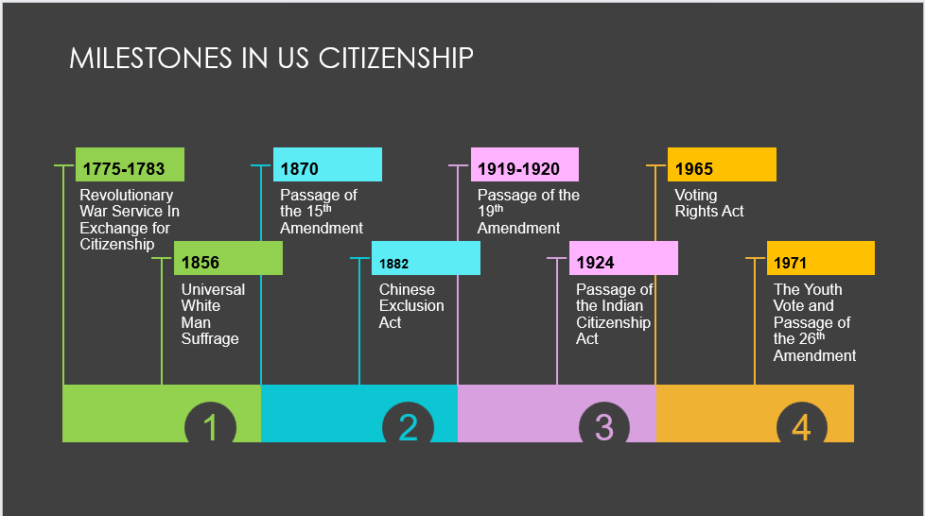Kristen Bailey PhD, ”Milestones in US Citizenship”
As the American colonies pushed for independence from Britain, they had several obstacles to face – one of which was the lack of a standing army. Even when patriotic speeches to enthusiastic settlers managed to gather men together to pick up arms against the British, how to pay those soldiers remained a vexing problem. The easiest answer was a promise – if you agree to help us in this fight, you will be recognized as a citizen of this nation.
However, when the nation was formed, there were no specific voting rights within the US Constitution, the eligibility of a person to vote was left up to the state where the individual resided. Most states limited voting to white men of a certain age who owned property – with the idea that these men had a vested interest in the issues they were voting upon.
- The idea of Universal White Male Suffrage grew in the antebellum period, and states began to drop property ownership restrictions, noting that many of the nation’s working men did not own property. In the state of Virginia, Universal Male Suffrage was extended to all residents in 1851 – almost one hundred years after Virginia’s first Constitution. This legislation was driven by men in the western counties – those that ultimately became West Virginia.
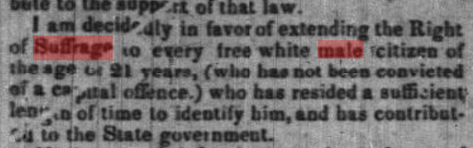
Virginia free press. (Charlestown, Va. [W. Va.]), 26 July 1850. Chronicling America: Historic American Newspapers. Lib. of Congress. <https://chroniclingamerica.loc.gov/lccn/sn84026784/1850-07-26/ed-1/seq-2/>
This was an issue that was global, and Americans fed off of news of advancements in voting rights in other countries, including France:
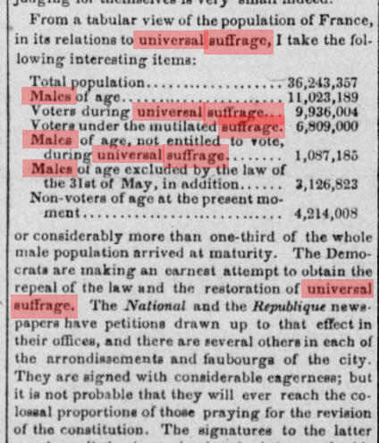
The republic. [volume] (Washington [D.C.]), 11 July 1851. Chronicling America: Historic American Newspapers. Lib. of Congress. <https://chroniclingamerica.loc.gov/lccn/sn82014434/1851-07-11/ed-1/seq-2/>
- Passage of the 15th Amendment to the Constitution
The United States Civil War is one of the major milestones of the nation moving towards a more comprehensive voting electorate – primarily because it helped establish that Black Americans were citizens. Establishing the right to vote and even recognizing Black Americans as citizens was not the original intention behind the acts that started the Civil War. Preventing the spread of the practice of enslavement to the American west motivated the conflict that began the war. The strong voices of Black Americans, who recognized this opportunity to secure not only their freedom from enslavement, but also their fundamental part of America as full citizens, forced the federal government to more deeply consider how to best protect those rights.
The ratification of the 15th Amendment removed the restrictive element of race from the right to vote, extending that right to all citizens. 15th Amendment to the U.S. Constitution: Voting Rights (1870) | National Archives. One of the most powerful pieces of art that addresses the purpose of the 15th Amendment is Thomas Kelly’s The Fifteenth Amendment, which gives the viewer the explicit understanding that what Black Americans desired was the right to cast a vote alongside all of the other rights that accompanied recognition as a full citizen. (Kelly’s print is a useful classroom exercise to ask students to recognize/understand the elements of full citizenship that had been previously denied, and that the 15th Amendment guaranteed). Note, however, the Fifteenth Amendment to the US Constitution provides that “Section 1. The right of citizens of the United States to vote shall not be denied or abridged by the United States or by any State on account of race, color, or previous condition of servitude.” – question – is securing voter registration processes that empower all citizens implicit in this amendment? “Section 2. The Congress shall have power to enforce this article by appropriate legislation.” Does this provide the federal government with the authority to oversee voter registration?

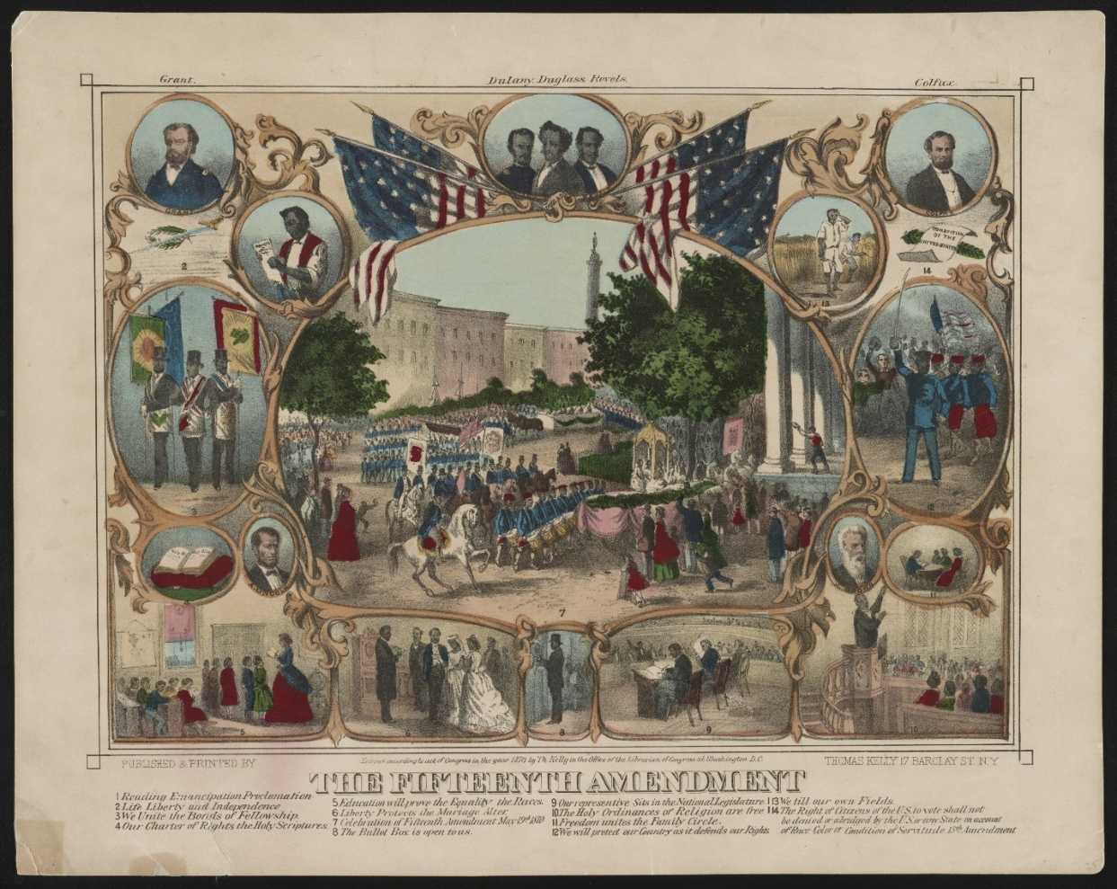
Kelly, Thomas, Active. The Fifteenth amendment. , ca. 1870. N.Y.: Published & printed by Thomas Kelly, 17 Barclay St. Photograph. https://www.loc.gov/item/93510386/. (saved in photos folder).
While the passage of the Fifteenth Amendment was a step forward, it also created two distinct issues related to voter registration. The text of the amendment said that “the right of citizens of the United States to vote shall not be denied or abridged by the United States or by a State on account of race, color, or previous condition of servitude –" Here, the point that had to be clarified was: were women citizens?
- Passage of the 19th Amendment
Well before the Civil War, women and those who supported the rights of women as citizens, began to push the federal government to recognize their right to be counted as citizens in order to vote. In 1827, Susan B. Anthony, along with several other women, were arrested for “voting illegally,” as were two inspectors at the election site who allowed the women to cast their ballots (accepted them as registered voters).
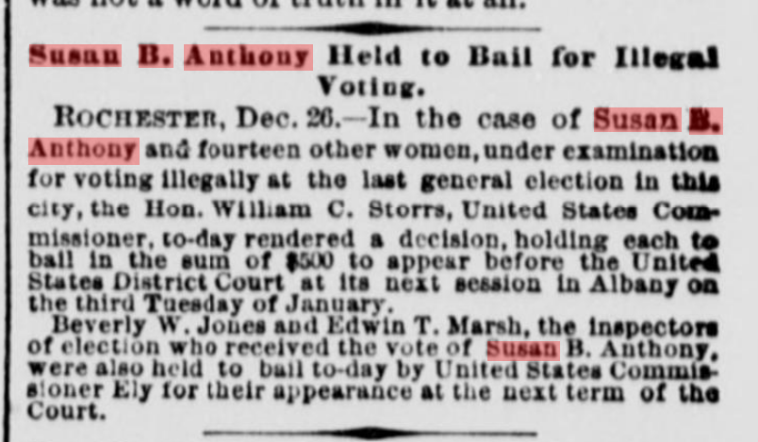
The sun. [volume] (New York [N.Y.]), 27 Dec. 1872. Chronicling America: Historic American Newspapers. Lib. of Congress. <https://chroniclingamerica.loc.gov/lccn/sn83030272/1872-12-27/ed-1/seq-1/>

The 19th Amendment, the result of decades of suffrage movements, broadened the federal definition of citizenship by including a provision that the right to vote could not be denied because of an individual’s sex. The women’s suffrage movement is also a good example of the global impact of voting issues – as women across the world sought to be recognized as full citizens of their respective nations. America’s push for suffrage was part of what’s known as the Transatlantic Women’s Suffrage Movement, which was fed by the efforts of Europeans (primarily the English). In 1848, a large gathering of women and supporters of women’s suffrage met in Seneca Falls, NY, where they produced the Declaration of Sentiments – their “call to arms” to the American people demanding that women be given “immediate admission to all the rights and privileges which belong to them as citizens of these United States.” Declaration of Sentiments - Women's Rights National Historical Park (U.S. National Park Service) -is a transcription of the declaration – the printed version can be found here: “Declaration of Sentiments” | Seneca Falls and the Start of Annual Conventions | Seneca Falls and Building a Movement, 1776&ndash;1890 | Explore | Shall Not Be Denied: Women Fight for the Vote | Exhibitions at the Library of Congress | Library of Congress. Modeled specifically after the nation’s own Declaration of Independence, the “list of grievances” section specifically ties a woman’s rights to citizenship and voting “Having deprived her of this first right of a citizen, the elective franchise, thereby leaving her without representation in the halls of legislation, he has oppressed her on all sides.” 1848DeclarationofSentiments.pdf
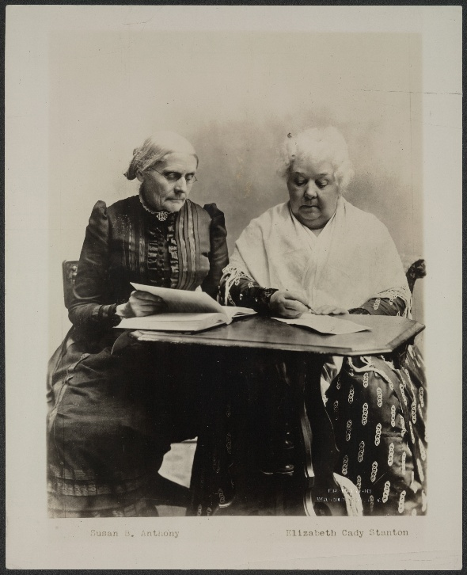
Susan B. Anthony and Elizabeth Cady Stanton. Two great pioneers in the Equal Rights cause. Without them, American women would not have progressed as far as they have in their fight for freedom. | Library of Congress. (saved in photos folder)
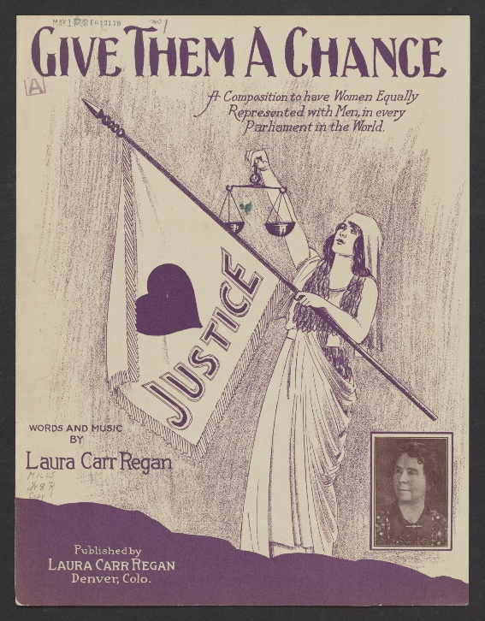
Give Them a Chance. composed by Regan, Laura Carr, Lyricist [Denver, Colo.: Laura Carr Regan, ©, 1926] Notated Music. https://www.loc.gov/item/2017562208/. (saved in photos folder)

In the 20th century, the argument persisted for suffragettes that it was not only their right, but their duty as citizens to register as voters and cast ballots to protect their communities.
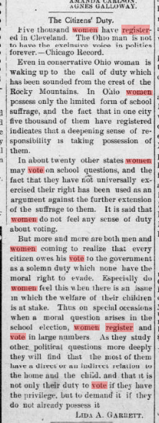
Western news-Democrat. (Valentine, Neb.), 19 April 1900. Chronicling America: Historic American Newspapers. Lib. of Congress. <https://chroniclingamerica.loc.gov/lccn/sn95069779/1900-04-19/ed-1/seq-5/>
There remained, however, members of American society who were not recognized as being full citizens – and they remained unable to register to vote because they could not meet the first question of eligibility - citizenship. The original residents of the land we call America struggled for more than a century to secure their rights as citizens. Like many other types of citizenship and voting legislation, this happened incrementally. The Choctaw Nation notes that, in 1888, women who had married US citizens were officially recognized as citizens. Similarly, in 1919, World War I veterans who were Native Americans were also named as citizens (again linking military service to citizenship). The military service of Native Americans was considered so important to the passage of these additional rights that their heroic actions during WWI was part of the argument to convince Congress to pass the 1924 Indian Citizenship Act.

- Indian Citizenship Act
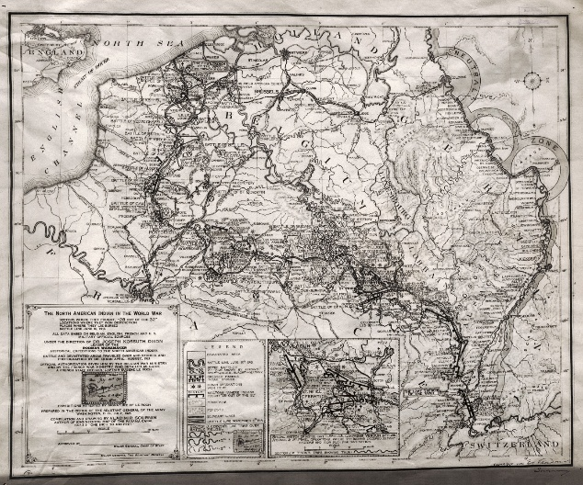
United States Adjutant-General's Office, Cartographer. The North American Indian in the World War. Washington, D.C.: Office of the adjutant General of the Army, July . ©1926, 1925. Map. https://www.loc.gov/item/2016586524/. (saved in photos folder)
In some instances, restrictions on Native Americans being able to register to vote was directly related to their residence on tribal lands, which was interpreted as their citizenship resting solely within that separate tribal nation. Military service and its long connection to citizenship helped push the nation closer to extending full citizenship to all Native Americans. In 1924, the Indian Citizenship Act was passed (also known as the Snyder Act), and recognized Native Americans born in the United States as full citizens.
Despite the specific inclusion of Black Americans and Native Americans as citizens, individual state controls over the right to qualify and register voters prompted tactics like Literacy Tests and Poll Taxes to limit voter registration. In some cases throughout the nation’s history, the extension of a federal right to vote has been met with violent conflict.
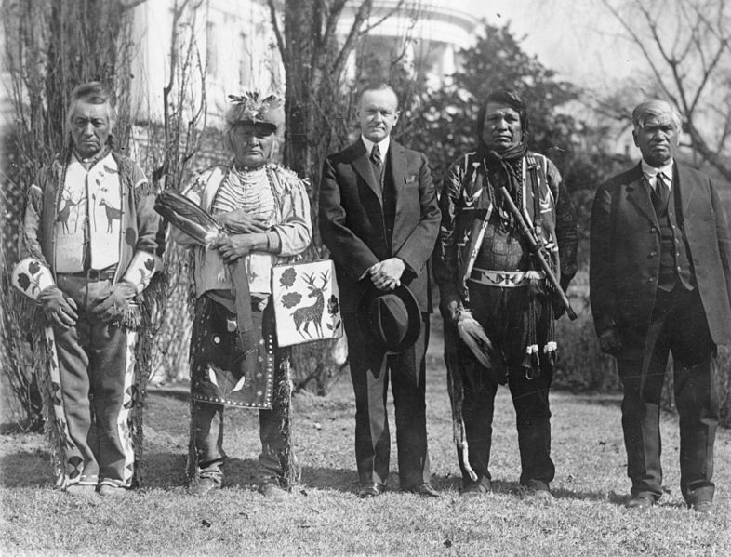
U.S. President Calvin Coolidge with four Osage Indians after Coolidge signed the bill granting Indians full citizenship. Library of Congress, National Photo Company Collection, LC-USZ62-111409. [President Calvin Coolidge posed with Natives, possibly from the Plateau area in the Northwestern United States, near the south lawn of the White House] | Library of Congress. (saved in photos folder).
- Passage of the 28th Amendment
This amendment extended the right to vote to citizens age 18 or older. Youth Vote | Voters and Voting Rights | Presidential Elections and Voting in U.S. History | Classroom Materials at the Library of Congress | Library of Congress
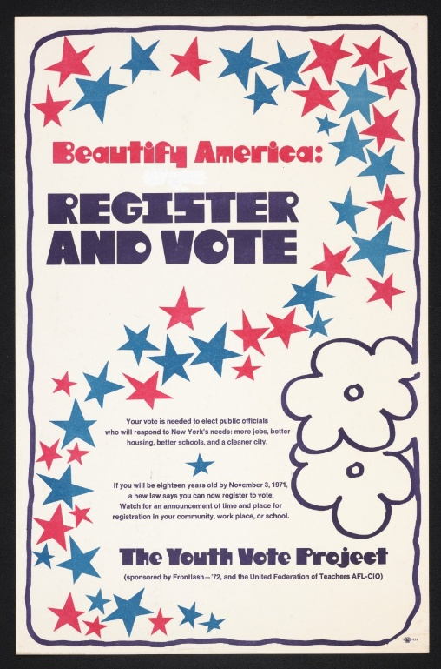
Frontlash Foundation, Sponsor/Advertiser, and Sponsor/Advertiser United Federation Of Teachers. Beautify America -- register and vote. New York New York State United States, 1971. Photograph. https://www.loc.gov/item/2016648055/. (saved in photo folders)
Encouraging the youth vote is particularly relevant to West Virginia. Senator Jennings Randolph introduced the 26th Amendment to the Constitution eleven times before its ultimate adoption in 1971 (proposed from 1942-1971). Jennings Randolph Award One of the fundamental reasons Randolph proposed the amendment was that, during World War II, President Roosevelt successfully pushed to lower the draft age from 21 to 18. Senator Randolph’s words - “If they’re old enough for bullets, they’re old enough for ballots.” Some in the country did not believe that young people had enough “common sense” to understand the nation’s critical issues in a way that would promote informed voting. The highly unpopular Vietnam War heightened public interest in the 26th Amendment. The Senate, in 1971, voted 94 to 0 to pass the 26th Amendment, and the US House of Representatives quickly passed the amendment as well. Public support in 1971 was high – and 38 states ratified the amendment within the same year. Randolph’s proposal – the 26th amendment, passed more quickly than any other amendment to the US Constitution. President Richard Nixon invited a group of young people to the White House when he signed the official document enacting the amendment into law. To remember Senator Randolph’s legacy, the West Virginia Secretary of State’s office awards high schools who register at least 85% of their eligible students for the vote. https://youtu.be/skaBkPAY89c.
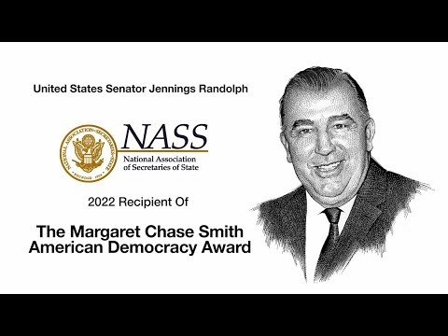

Ongoing issues related to citizenship and voting: (questions of gender – as opposed to sex)

Component 2: Contested Citizenship: Barriers to Voter Registration

Following the passage of the Fifteenth Amendment, many states within the former Confederate States of America saw a rise of violence during election times, as Black Americans attempted to use their newly granted right to vote. Some areas, such as Hamburg, South Carolina, were home to groups called Rifle Clubs – men who gathered together under the guise of holding shooting competitions and marching in parades, but who also had a much more nefarious intent, that of preventing Black men from participating in voting.

Hamburg Massacre | South Carolina Encyclopedia and The Charleston Museum | News and Events » “Waving the Bloody Shirt:” Reconstruction Era Violence and Political Identity Content warning for language.
Other attempts to limit voting for Black Americans in the South included the use of literacy tests, which posed complicated questions about the elections process, the US Constitution, or state laws on voting to voters who attempted to cast a ballot. Those who were unable to successfully answer the questions could be deemed not sufficiently informed to cast a ballot. Because the tests could be administered at the discretion of the local voting boards, tests were typically only given to groups who those in political power hoped to limit from voting.
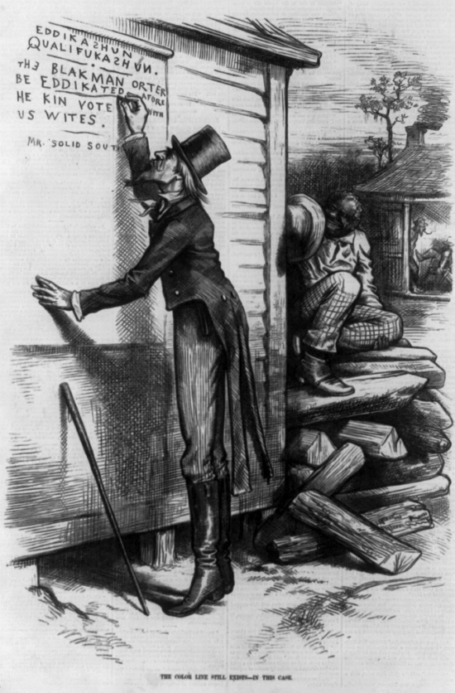
Editorial cartoon criticizing the usage of literacy tests for African Americans as a qualification to vote. Cartoon shows man "Mr. Solid South" writing on wall, "Eddikazhun Qualifukazhun. The Blak man orter be eddikated afore he kin vote with us Wites, signed Mr. Solid South." An African American looks on. Illustration in: Harper's Weekly, v. 23 (1879 Jan. 18), p. 52. This image is available from the United States Library of Congress's Prints and Photographs division
under the digital ID cph.3b29638.

The Deep South, states that had primarily been associated with the former Confederate States of America, continued to restrict voter registration for Black Americans through the 19th and 20th centuries. Things came to a violent head during the summer of 1964, which is commonly referred to as Freedom Summer. Several civil rights organizations around the country targeted the state of Mississippi with a mission to create an overarching program to enhance voting rights. Volunteers numbering close to 1,000 came to Mississippi to build schools and libraries, host meetings to educate the public about voting rights, and conduct voter registration. The white power structure within the state did not respond well to these efforts. Volunteer workers were beaten, churches (the most typical meeting place for the volunteer groups) were bombed or burned down, more than 1,000 people were arrested, and four civil rights workers and three citizens were murdered.

https://youtu.be/fx_5B0MVeqk?si=5FSh6z-MM4H4t6TK
Freedom Summer | National Archives
Foner (Thomas) Freedom Summer Papers - Digital Archives - Mississippi Department of Archives and History (there are some good photos here). Details about public use (for “research, teaching, and private study”) can be found here: General & Tech Data - Foner (Thomas) Freedom Summer Papers - Digital Archives - Mississippi Department of Archives and History

Foner, Series 3 photographs, 2312-1-3-25
DOCID-70000876.PDF (FBI Records related to the 1965 March from Selma to Montgomery) – this is a larger file (64 pages), however, these would be good primary source documents for students to look at, as many relate to both local and national groups working towards voter registration in Alabama. (**language caution)

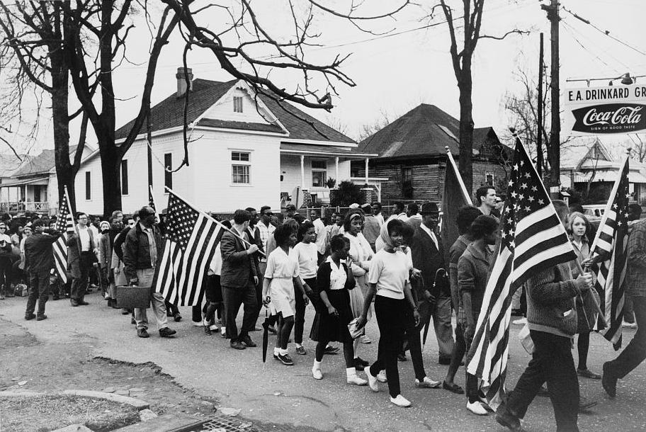
Participants, some carrying American flags, marched from Selma to Montgomery, Alabama, in the 1965 Civil Rights March. Public Domain Image. Pettus, Peter, photographer. Participants, some carrying American flags, marching in the civil rights march from Selma to Montgomery, Alabama in. Selma Alabama, 1999. [or 2000 from a Photograph Taken in 1965] Photograph. https://www.loc.gov/item/2003675345/. (saved in photos folder).

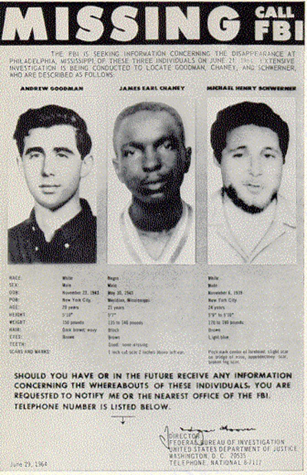
File:FBI Poster of Missing Civil Rights Workers.jpg - Wikimedia Commons

Component Three - Voter Registration and Technology
The first attempt to regulate voter registration and keep a full record was the "Massachusetts system" – based on the state of Massachusetts and the first attempt to “pre-register” voters before they came to the ballot. One of the primary ways to become qualified to vote was the prove that taxes had been paid – so this system was a check to ensure that only people with a vested interest in the community (proven by their ownership of property and their fulfillment of their tax obligations on that property) were making decisions about issues up for a vote.
Historian Alexander Keyssar notes that cities were the first places to implement advance registration procedures. Urban locations, with many transient residents and immigrants meant that election officials had a more difficult time identifying eligible voters. New York City was a hotbed of election conflict, and the state’s first registration law in 1840 was only applicable within the city. There, the law was implemented by members of the Whig Party, who believed Irish immigrants were becoming too powerful as a voting bloc.
Prior to the implementation of private/paper ballots marked in silence and deposited with an assurance of anonymity in a ballot box, voting was much more personal for the voter. John Wise gives a great description of viva voce voting in Virginia – to give the vote orally rather than in writing. Through the mid-nineteenth century, voters approached election officials, where they were asked directly who their selection was for the candidates. The voter pronounced his choice, and his vote was recorded and announced to anyone gathered at the polling spot. You can imagine the courage it might have taken to have voted differently than your neighbors or against your brother-in-law!
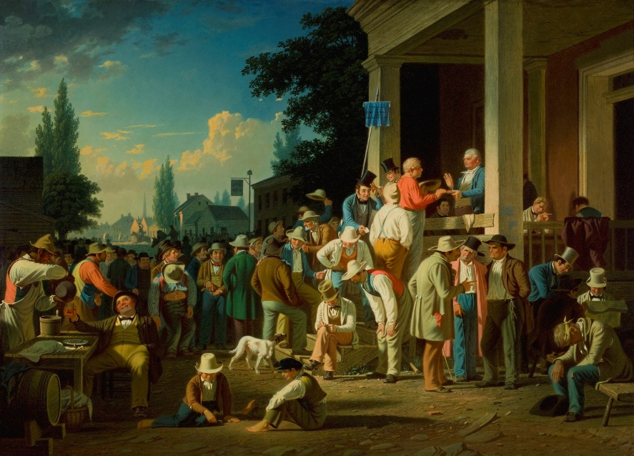
George Caleb Bingham, The County Election, 1852 painting (Saint Louis Art Museum image in the public domain saved in images file). The County Election - Saint Louis Art Museum.
In the post-Civil War years, immigrants (at this time primarily Irish and German) were targeted by men like William “Boss” Tweed, who offered jobs and bribes in exchange for votes. Tweed was not only an ambitious politician himself (primarily in local politics in New York City), but he was integral to the Tammany Hall Democratic Party machine. Elections were so malleable at the time, that Tweed was able to use several tactics to influence the vote. He hired people to go to various wards and cast ballots to get the result he wanted; he bribed election officials and inspectors to look the other way; in some instances, he simply had the election results falsified and the winners he wanted were announced. Inadvertently, Tweed really did help the immigrant population in New York City – because he had men pushed through the naturalization and voter registration for many who had just arrived in the city.
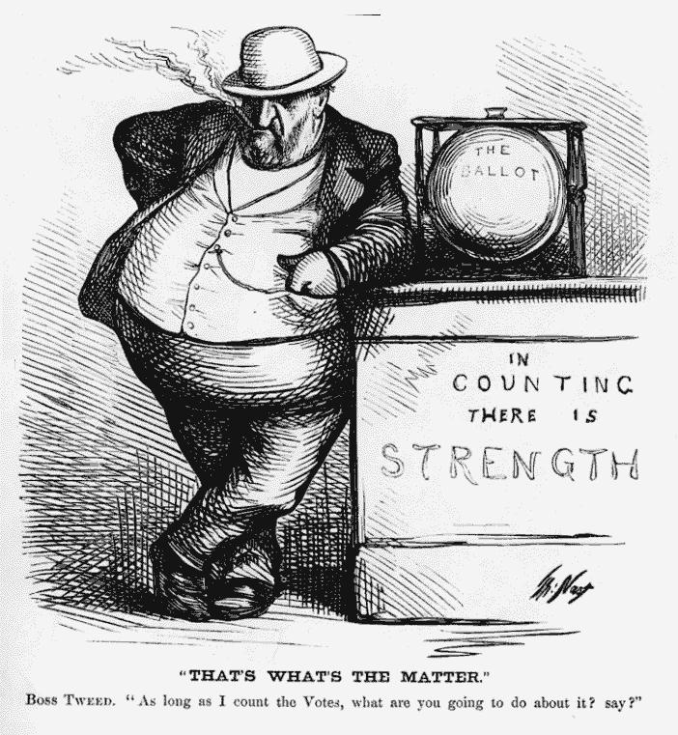
Cartoon by Thomas Nast, Harper’s Weekly, October 7, 1871, 944
(Wikimedia Commons public domain image saved in images file) File:Boss Tweed, Nast.jpg - Wikimedia Commons.

Pre-registration was historically often used as a way to limit, rather than increase voter participation. Examples from Keyssar:
- 1866: All voters in New Jersey had to register the Thursday prior to the election (what if you can’t take off work on Thursdays?)
- 1878: San Francisco voters had to register in person before every single election
- 1880s: Voters had to be seen by the election judge at their precinct on a Tuesday to make an affidavit to prove they were eligible to vote.
- 1908: New York City required voters to do their registration on Saturdays (which was inconsistent with practices of the Jewish faith).
Voter ID laws – requirement of “an approved, government-issued form of ID.” Some states (Texas) provide citizens with the ability to obtain a free “voter id.”

- Modern Methods, Key Legislation, and Proposals for Advancing Voter Registration
National Voter Registration Act of 1993 (NVRA) – often called “Motor Voter,” this federal legislation made it possible for Americans to register to vote while transacting business at other state offices (most notable, their state’s Department of Motor Vehicles). This law also said that states could not impose registration deadlines more than thirty days before an election.
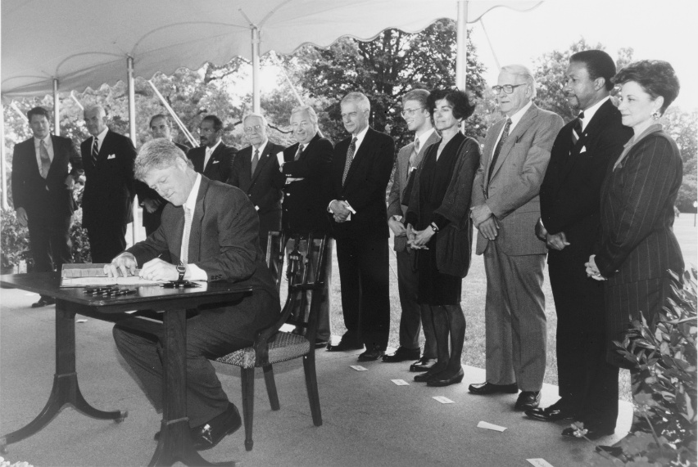
President Bill Clinton signing the National Voter Registration Act of Motor Voter Act, as Vice-President Albert Gore and notable members of Congress look on. , 1993. Photograph. https://www.loc.gov/item/95502982/.
Help America Vote Act (2002 – HAVA), required states to build in additional provisions to a computerized statewide voter registration list, including making allowances for mail-based registration of voters.
April 1, 2016 – West Virginia joins two other states by passing a law allowing automatic voter registration when eligible citizens conducted business at the Department of Motor Vehicles.
As of October 2023, Automatic Voter Registration was implemented in twenty-three US states and the District of Columbia. This method requires an individual to make a choice to not register to vote – if you don’t opt out, you are now registered to vote if you use the state systems that support this process.
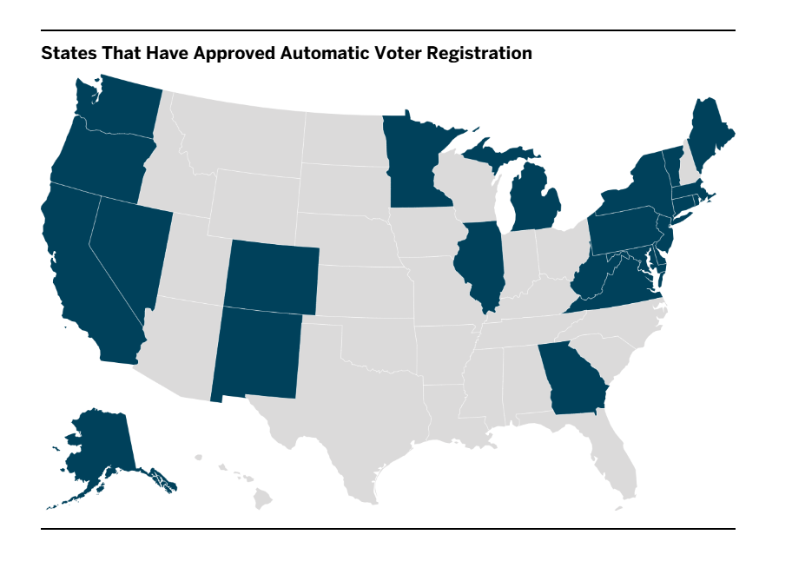
Health Care-Based Voter Registration – this 2024 study “suggests that health care-based voter mobilization reaches a distinctly younger and more racially and ethnically diverse population relative to those who reported contact from political campaigns.” Study related to a 2020 founded organization called Vot-ER. McCabe, Katherine, Yinlu Zhu, Simar S Bajaj, and Alister F Martin. “Increasing Voter Participation through Health Care-Based Voter Registration.” JAMA Health Forum 5, no. 6 (n.d.): e241563. https://doi.org/10.1001/jamahealthforum.2024.1563.

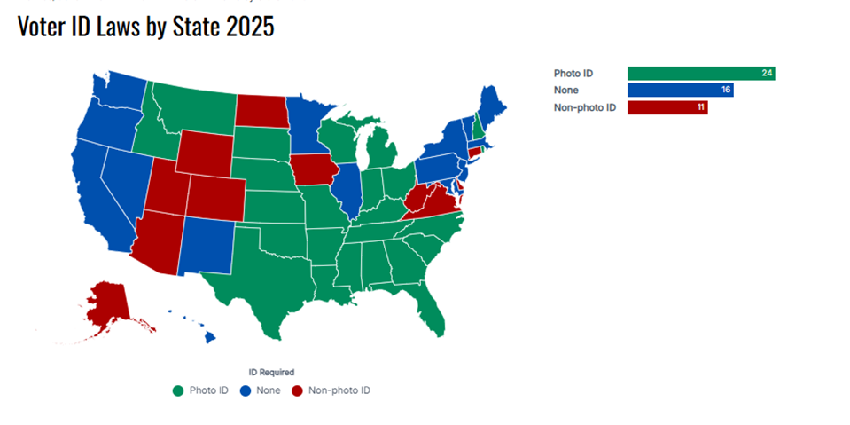

The ongoing process of implementing ways to maximize voter registration has not ended. On February 7, 2025, Sarah J. Eckman published “Voter Registration: Recent Developments and Issues for Congress.” Same-day voter registration is one of the measures that appear in Eckman’s “Selected Legislative Issues Related to Voter Registration.” Eckman notes for Congress that the District of Columbia and twenty-one states currently utilize same-day voter registration. Three other states (Alaska, Montana, and North Carolina) have modified same-day voter registration. The primary objections raised to same-day voter registration are:
- Difficulty verifying the information provided by voters at the same time an election is being held
- Impedes the ability of election officials to process the application of a voter
- Longer wait periods for voters could occur with increased volume at polling sites
- Additional staff (with associated costs) required to handle same-day voter registration
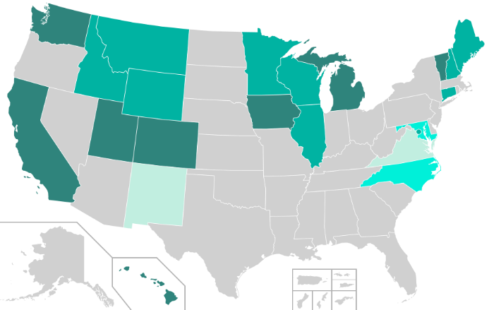
2018 Map of Same-Day Voter Registration
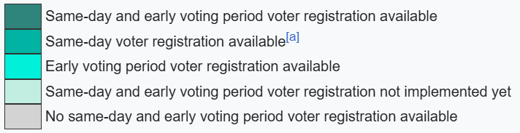

Voting and Fraud
The Oxford Handbook of Electoral Systems notes that systems of registering voters serve two primary purposes, which can be at odds with each other: ensuring that persons who are eligible to vote are able to do so, and, in many instances, a tool to limit participation of particular groups of people (typically marginalized groups in society). Voter registration methods may vary from state to state, or nation to nation, but they can be used to help limit election fraud. This lesson component will ask students to consider:
- historic examples of real (or imagined) voter fraud and the purposes that fraud served
- risks to democracy that accompany voter fraud
- cautions that must be taken to prevent fraud
- ways in which inaccurate reports of fraud are also problematic to democracy
What is Electoral Fraud?
The ACE Project’s Electoral Knowledge Network distinguishes individual and group/government fraud, which helps us understand that there can be threats to democracy in small and big ways connected to voter registration fraud.
Individual Fraud
- Impersonating another voter in order to cast more than one ballot
- Using the name/identity of a deceased person to cast more than one ballot
- Using a mail-in ballot meant to represent the vote of another person
Group/Government Fraud
- “Stuffing the Ballot Box,” or counting ballots improperly, adding ballots that were not really voted to the ballot box, improperly confirming vote totals known to be inaccurate in order to secure a specific result.
- Intimidation – discouraging people from registering to vote, or trying to prevent a registered voter from casting a ballot.
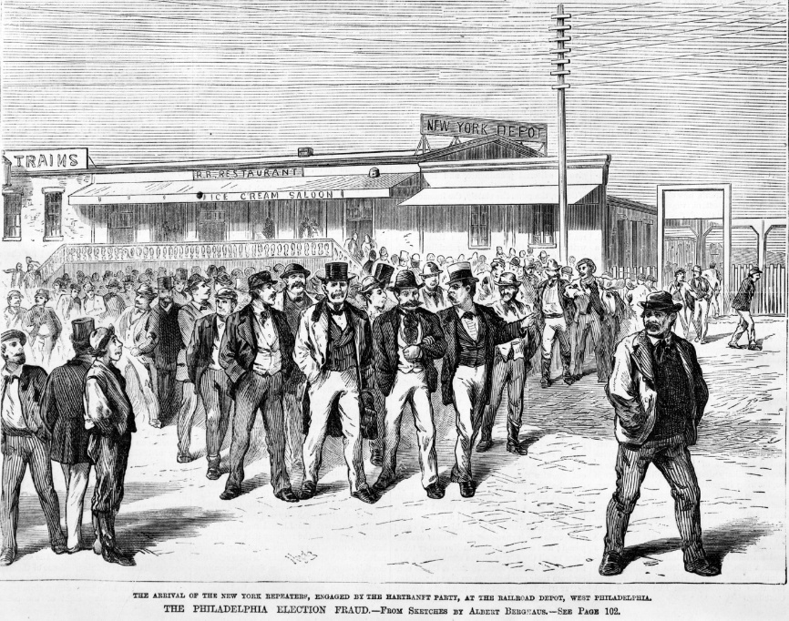
This image shows a train station in Philadelphia during a hotly contested governor’s race in 1872. New York goons called the “Repeaters” were brought to Philadelphia from New York by the Philadelphia Republican Party to vote for the Republican candidate, John Hartranft. ExplorePAHistory.com - Image. (image is noted to be public domain by Wikimedia and is saved in images folder).
Participation in group/government voting fraud has historically been both potentially lucrative for some, and restricted the rights of others.
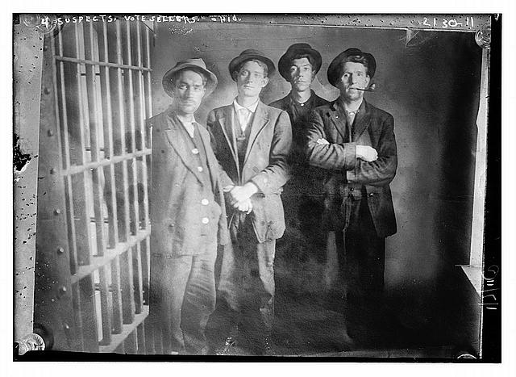Four Suspects, Vote Sellers: https://www.loc.gov/pictures/item/2014688909/
This undated image show four men who were incarcerated for attempting to sell their votes – attempting to earn a few dollars in exchange for casting their vote as directed.
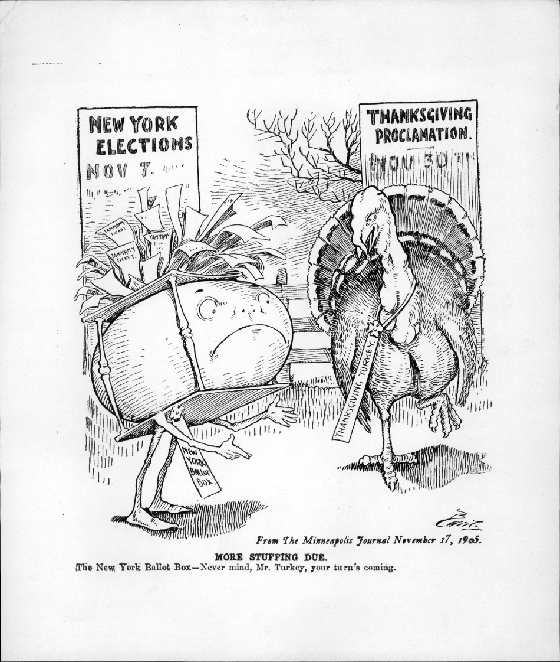
Charles Lewis “Bart” Bartholomew’s 1905 political cartoon illustrating ballot box stuffing in the Tammany Hall political machine system in New York. More Stuffing Due | DPLA

Component Four - Same-Day Voter Registration – A Global Overview
How does America measure up with the rest of the world in terms of voting technology and attempts to make election processes simple and available to the largest number of citizens?
A report from FairVote Research, a non-partisan group that investigates voting, explains that the United States is one of the only democracies around the world that does not control the registration of eligible voters. This is because the rights of individual states to monitor election practices from within has long been a highly valued right in our country. Around the world, however, the more common practice is that all citizens are automatically registered to vote upon reaching their country’s eligible voting age. Microsoft Word - Universal Voter Registration-4-21-09.doc
The Brennan Center for Justice (part of the NYU School of Law) considers four important parts of basic voter registration systems:
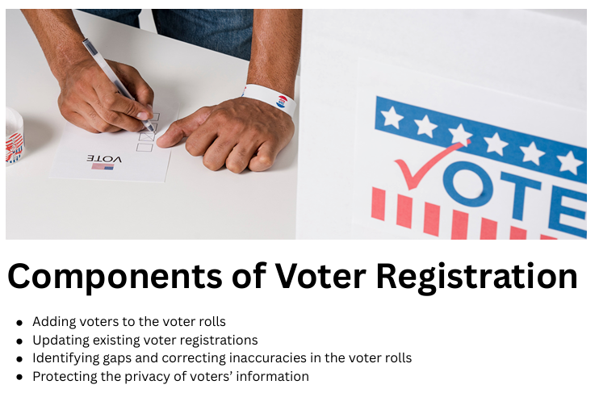
Same-day Voter Registration is a method that can be used to accomplish each of these components.
Adding Voters to the Rolls: A sampling of countries around that world who are proactive in registering voters include:
- systems that automatically register young people once they become of eligible voting age; example: all French citizens who turn 18 years of age are required to attend a one-day national defense session, during which time their names are record and enrolled as voters
- using data from other government systems; example: at age 16, Argentine citizens must obtain a national ID card; their information is recorded, and they are automatically enrolled as voters
- using information in databases known as civil registries; example: in Germany, local “household registries” are taken to keep track of things like municipal taxes owed; once registered, the names of citizens are then provided to larger civil registries for voter enrollment
- generating direct mailing of voter registration information to the public; example: in 2003 in Indonesia, a register of citizens collected door-to-door was uploaded into a database, automatically enrolling people as voters.
Updating Existing Voter Records: The use of systems that are automatic and cross-reference other types of citizen data management can ensure that names and addresses are correct across systems and can help reduce voter fraud by removing the names of deceased voters from the election rolls.
Identifying Gaps and Correcting Inaccuracies in the Voter Roles: some methods that countries around the world use to ensure that their voter registration rolls are accurate include publishing voter lists so that citizens can self-monitor their registration and performing outreach in remote areas to help make corrections. A system that is currently used and is related to Same Day Voter Registration is installing systems of voter updates that can be used on Election Day.

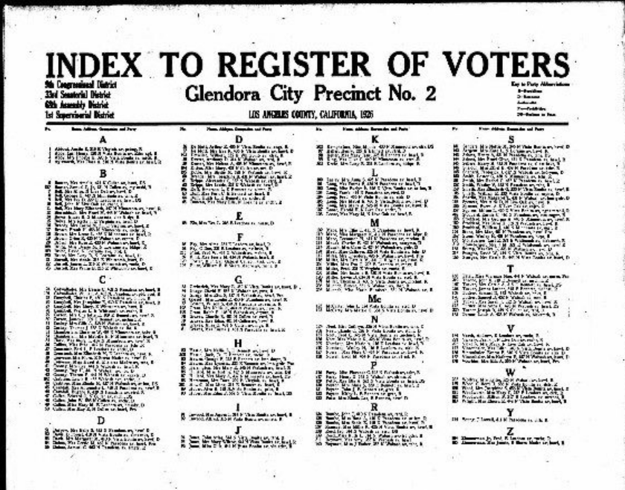
The Pew Research Center notes that, of the 226 countries/territories on Earth – 122 have compulsory voter registration. In many cases, registration is accomplished through the use of other types of government record-keeping, such as a census. In these cases, voter registration is both compulsory AND automatic. How elections work around the world | Pew Research Center.

A Map Showing the Flags of the World in 2024 File:Flag Map of The World (2024).png - Wikimedia Commons

Many who look at voter registration around the world criticize the US’s decentralized system, which puts the burden of the process onto the voter, as one which makes reform complicated and undermines participation.¹ This map, made available from The Electoral Knowledge Network, illustrates how voter registration authority is dispersed around the globe:

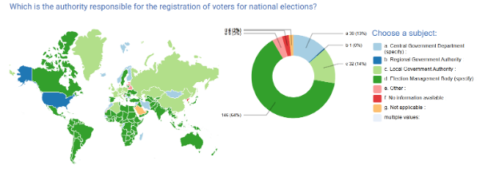
Authority Responsible for Voter Registration – ACE Comparative Data —
A study from the Institute for Responsive Government considered three of the world’s most progressive and proactive voter registration systems:
Germany, which relies nearly exclusively on civil registries (held with local authorities) to enroll voters, has significantly reduced the extra work required by voters – because citizens are already obligated to register their residency for other types of government-sanctioned activities. The German election officials are also pro-active in ensuring voter rolls are accurate and complete. At least twenty-one days prior to any election, voters are given notice of their status with the election system – they can check their polling place, voter registration number, and other details, to make sure they are ready to vote.
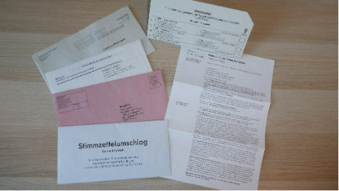
Postal voting documents for the 2024 European Parliament election in Germany. These are the postal voting documents for Berlin, Spandau District. The number of the voter invitation card and electoral roll were subsequently removed. File:Briefwahlunterlagen Europawahl 2024 (Germany).jpg - Wikimedia Commons

Australia has a voter registration rate of 97.8 percent! This is in part due to their highly centralized method – voting is overseen by the Australian Electoral Commission (AEC), which has been in control of the country’s election processes since 1918. Like Germany, Australia utilizes civil records – such as Drivers’ Licenses, Tax Records, and others, to build their voter rolls. Young people are offered the option to “pre-enroll,” to ensure that they will automatically be on voter rolls by their eighteenth birthday. Another important distinction for Australia is their focus on reaching indigenous populations, in an effort to ensure that all Australians are proactively protected and registered to vote. Comparative Voter Registration: Lessons from Abroad for Improving Access and Accuracy in the United States - Institute for Responsive Government.

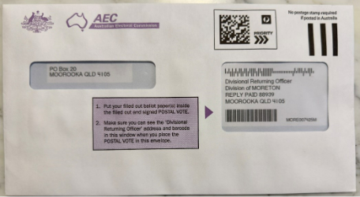
Postal voting envelope at the 2023 Australian Indigenous Voice referendum File:Postal voting envelope at the 2023 Australian Indigenous Voice referendum.jpg - Wikimedia Commons

Canada, like the systems of both Germany and Australia, has a centralized oversight with its “Elections Canada” agency. This system has a built-in collection method which brings in citizen data from forty other government agencies. This system puts existing data to work to ensure that Canadians are registered to vote, which has resulted in a current level of 95% registration rates for eligible voters.
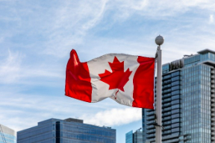
National flag of Canada on Canada Place in Vancouver, British Columbia, Canada File:Vancouver (BC, Canada), Canada Place, Kanadaflagge -- 2022 -- 1896.jpg - Wikimedia Commons

The biggest takeaway, by far, is that centralized systems tend to be the common denominator that drives global voter registration systems that are highly successful. In a highly mobile United States, which values the independence of its individual state authority, moving towards a more comprehensive, centralized federal system that shares data is a complicated question, but one which deserves additional scrutiny.

Reform initiatives in the US
Automatic Voter Registration – as of 2024, there were 37 states utilizing systems of automatic registration – with most of those systems requiring a specific “deselection” if a person does not want to register to vote. One of the most common of these systems is the utilization of state Department of Motor Vehicle transactions as an opportunity to register to vote. Online voting systems, which combines digital registration with later in-person proof of identity, have met with pushbacks in several states. Comparative Voter Registration: Lessons from Abroad for Improving Access and Accuracy in the United States - Institute for Responsive Government. All this research points to a need to strongly consider the role that Same-Day Voter Registration might play in securing easier access to voter registration for eligible voters in the US.
One of the major concerns in America about voter registration remains the idea of fraud – or how we can best maintain election integrity.
Students should be asked to consider these issues:
- First – why should election integrity matter to them?
Students might consider the ways that elections shape public policy and, if elections are not reflective of the body of people served, policies may be implemented which benefit the few, but do not provide the best use of public tax funds.
The Electoral Knowledge Network proposes that these are the elements of electoral integrity that best ensure protection for all eligible voters:
“Under the principles of electoral democracy, all citizens have equal rights to:
• participate as voters and candidates;
• all citizens must have equal voting power;
• the secrecy of the vote must be assured;
• voters must have meaningful access to electoral and campaign information;
• election administration must be conducted in a fair and non-partisan manner;
• elections must be held regularly;
• the results of elections must be decided by the freely cast votes of the citizenry.”²
- Secondly – are there reasons why same-day voter registration could pose a threat to electoral integrity?
Students should be asked to weigh in on implied threats to electoral integrity that have been suggested by the America First Policy Initiative (Republican-based). These include:
Election officials do not have time and resources to ensure voter eligibility, which could lead to the casting of fraudulent votes.

After students have considered the concept of same-day voter registration and threats to electoral integrity, an in-class exercise could be held to gauge how common arguments for and against same-day voter registration land with informed students.
Armed with two faces – students will indicate how these arguments rank with them and will be prepared to answer questions about why they responded favorably or unfavorably. 

- Same-day registration increases voter turnout
- Same-day voter registration combats voter suppression
- Same-day voter registration brings out increased numbers of young voters
- Same-day voter registration increases the chance for fraudulent ballots
- Same-day voter registration is too costly
- Same-day voter registration causes chaos at polling places
Additional Source Material:
Gilder Lehrman
The Right to Vote | Gilder Lehrman Institute of American History
Exhibitions | Gilder Lehrman Institute of American History
Who Can Vote? A Brief History of Voting Rights in the US | Gilder Lehrman Institute of American History
Smithsonian Institution:
- Votes for Women: A Portrait of Persistence Poster Exhibition – Free – ten full-color posters, user guides, and handbook.
WV State Museum
- Types of Elections PPT.pptx and Types of Elections in West Virginia Lesson Plan.pdf
- Automatic Voting Booth
WVRHC
- Collection: Monongalia County Voter Registration | West Virginia University Archivesspace
- Summers County Politics (prints, negatives, newspapers, clippings; photos of politicians; voter registration forms, election results, articles and information about elections), ca. 1975-2002 | West Virginia University Archivesspace
- Collection: Kanawha County Poll Book | West Virginia University Archivesspace
- Collection: Reverend Sampson Miller, Collector, West Virginia Election Supplies Boxes | West Virginia University Archivesspace
- Collection: Political Campaigns and Elections Material | West Virginia University Archivesspace
- Item 87; Muster Roll (Copy) -- Copy of the Names of Jacob W. Marshall Guerilla Band, Roll Company J, 19th Virginia Cavalry. Note on last page indicates that some of these men pass themselves off as Union men to register to vote, 1861 | West Virginia University Archivesspace

Voting in America - The Henry Ford

Case Study 2: Absentee Voters
This lesson plan outlines a multi-pronged approach to discussing mail-in and absentee voting. Teachers may choose to follow the sequence provided or select elements that best complement their existing instruction.
This lesson plan addresses WV College and Career-Readiness Standards for Social Studies (2520.4) with the following components:
- Civics – by specifically covering the history and practice of absentee voting, this lesson plan is directly on point to help prepare "students to be informed, active and effective citizens who accept their responsibilities, understand their privileges and rights and participate actively in society and government." Grades 6–8 will be able to appropriately place absentee voting history within the context of the US Civil Rights movement and wartime expansions of voting rights. Grades 7–12 will be able to analyze the rights and responsibilities of citizens as they relate to voting and the ways in which absentee voting can enhance or challenge those rights and responsibilities.
- Geography – analyzing absentee voting at the local, national, and global levels helps students understand their relationship with the world as a whole. Grades 6–8 will consider ways in which geography, such as population mobility, distance from polling sites, and rural access, can impact absentee voting. Grades 7–12 will use geographic skills to analyze absentee ballot access across physical, social, and economic spaces, particularly during public health or natural crises.
- History – bringing in specific examples of absentee voting practices of the past introduces students to critical thinking skills about the evolution over time of this element of society. Grades 6–8 will benefit from lesson plan elements targeted at West Virginia’s own adaptations to absentee voting. Grades 7–12 will consider how absentee voting policies have evolved in response to national crises and political shifts, enhancing their ability to interpret the political, social, and economic impact of these changes.
- Economics – beginning with Grades 6–8, this lesson plan asks students to analyze the ways in which the economic background of citizens has been directly relevant to absentee voting practices. For Grades 7–12, lessons on absentee voting can reinforce the ability to analyze how economic hardship, employment demands, and administrative costs influence the structure and availability of absentee voting systems.

​​Components of Absentee Voting to Consider Throughout All Lesson Plans
- General background about Absentee Voting
  - Include a brief history of how absentee voting has developed in the United States and the circumstances that led to its initial use (e.g., Civil War, World War II, UOCAVA) and broader expansion (e.g., COVID-19 pandemic).
- Explore with students the values that relate directly to absentee voting:
  - Access – Ensuring that eligible voters can vote by mail, especially those serving in the military, with disabilities, or living abroad.
  - Representation – Ensuring all citizens have an equitable opportunity to participate in elections, even if they cannot vote in person.
  - Security – Protecting against fraud while not unduly burdening voters through:
    - Signature verification and ballot tracking
    - Secure ballot collection/drop-off procedures
  - Efficiency – Evaluating how absentee voting helps streamline election administration, reduce in-person congestion, and provide cost-effective solutions.
  - Fairness – Assessing how absentee voting systems treat voters equitably across geography, ability, and socio-economic status.
  - Historic Example: Civil War-era soldier voting laws.
  - Current Example: Expansion of absentee voting during the COVID-19 pandemic.
- Explore with students the potential barriers to the protection of the values associated with absentee voting:
  - Access:
    - Postal delays, confusing deadlines, or technical ballot request processes
    - Language accessibility issues for non-English speakers
    - Disinformation about mail-in voting processes
    - Historic Example: Ballot access restrictions for Native American voters living on reservations
    - Current Example: Ballot rejection due to missing or mismatched signatures
  - Representation:
    - The lack of cure processes for rejected absentee ballots disproportionately affects marginalized groups
  - Security:
    - Allegations of fraud, tampering, or procedural inconsistencies can undermine trust in absentee ballots
  - Efficiency:
    - Uneven processing times and administrative burdens in high-turnout elections
  - Fairness:
    - Voter ID laws or restrictive ballot requirements that may impact certain communities more than others
- Explore the model of Absentee Voting:
  - Examine state-by-state differences in absentee ballot rules (e.g., no-excuse vs. excuse-required)
  - Discuss implementation examples of universal vote-by-mail in states like Oregon and Colorado
  - Analyze public policy reports and legal frameworks around absentee voting
- Explore with students public campaigns surrounding Absentee Voting:
  - Highlight arguments for and against absentee voting
  - Examine media coverage, advertisements, and infographics that frame public perceptions of mail-in ballots
- Simulate Absentee Voting in the Classroom:
  - Create a role-playing or hands-on simulation where students request, complete, and return absentee ballots under varied circumstances
  - Introduce barriers such as delays, signature mismatch, or unclear instructions to help students understand real-world challenges.

Component 1: The History and Expansion of Absentee Voting
Keeping in mind that the right to vote and access to the ballot are not always equally distributed, this lesson will explore the origin and evolution of absentee voting in the United States, with attention to who has historically had access to vote by mail and under what conditions. Students will consider the role of crises (like war and pandemics) in reshaping the electorate through absentee policies.
Note: The Constitution does not explicitly grant the right to vote by mail. What, then, is the role of federal oversight in securing fair absentee voting practices? The Elections Clause (Article I, Section 4) gives Congress the power to regulate elections. Should absentee voting be included in this regulatory scope?

Civil War Beginnings: Voting from the Battlefield
The origins of absentee voting in the United States trace back to the Civil War, when the need to accommodate Union soldiers serving on distant battlefields prompted the first legislative efforts to expand voting access beyond the traditional polling place. Prior to this, voting was a highly localized, in-person activity, with few exceptions made for those unable to appear at their polling station. But with hundreds of thousands of men enlisted in the military and stationed far from home, a political and logistical question emerged: how could these citizens participate in elections while fulfilling their duties on the front lines?
Between 1862 and 1864, over a dozen Union states passed temporary war-time laws that permitted soldiers to vote in absentia. These laws varied widely from state to state. In some places, military ballots were issued and returned via courier or mail to local election officials. In others, election commissioners or designated agents traveled to army camps to administer the voting process on-site. Some states allowed soldiers to authorize a proxy, a trusted person back home, to cast a ballot on their behalf.
These early absentee voting systems required creative legal frameworks and often included strict authentication protocols to prevent fraud, such as requiring signed affidavits, officer witnesses, or regimental verification. Despite such safeguards, absentee voting was controversial, particularly among Democrats who feared the soldier vote would favor Abraham Lincoln and the Republican Party.
Nevertheless, by the 1864 presidential election, an estimated 150,000 Union soldiers voted by absentee ballot. Their participation proved decisive in many close races and helped secure Lincoln’s reelection. The Confederacy did not pursue similar absentee voting systems, viewing them as potentially disloyal or unfeasible given the decentralized nature of its military infrastructure.
The Civil War set a precedent for absentee voting in America, establishing both the practical mechanics and the ideological debate over balancing access and integrity. The wartime voting systems developed in this era would influence future absentee voting policies, especially during times of national crisis or overseas military engagement.
- Inquiry Prompt: Who was allowed to vote absentee in this period? What mechanisms were used to secure the ballots? How did these policies reflect both trust and suspicion?
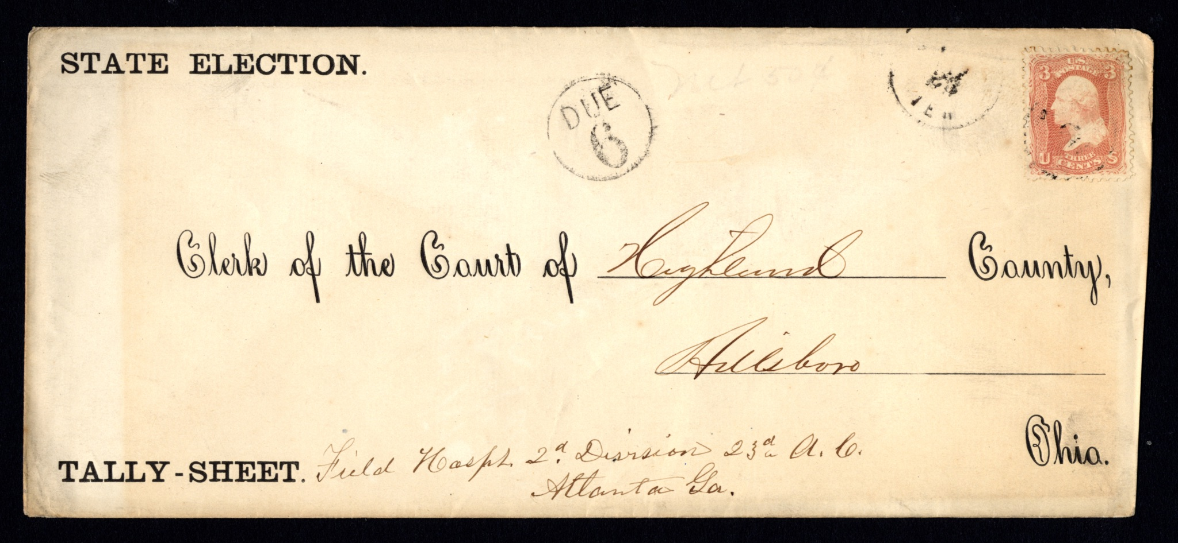

Civil War election cover, 1864. National Postal Museum.
The state of Ohio created envelopes for their registered voters in the military to vote absentee and mail in their votes for both the presidential and state elections of 1864. This envelope, sent from a Union Army field hospital in Atlanta, Georgia, contained a tally sheet recording the votes of Highland County soldiers for the Ohio state election. The museum does not have the tally sheet that was carried in this envelope in its collection.
https://archive.org/details/endofera01wise/page/54/mode/2up

Codifying Absentee Voting: Wartime and Overseas Voting Laws
Fast forward to World War II, and the need for absentee voting became even more urgent, and widespread. With over 16 million Americans serving in the armed forces, the federal government and states expanded absentee voting to a national scale. Unlike during the Civil War, when procedures varied state by state and were often temporary, absentee voting in WWII was more systematized. States collaborated with federal agencies to distribute ballots to military personnel stationed across Europe, the Pacific, and other distant locations. While logistical challenges remained, like delayed mail and inconsistent ballot returns, the war demonstrated the necessity of building a more reliable absentee system.
The legacy of WWII-era absentee voting laid the foundation for permanent legislative change. In 1986, Congress passed the Uniformed and Overseas Citizens Absentee Voting Act (UOCAVA), a landmark law that formally guaranteed the right to vote by absentee ballot for:
- Members of the U.S. Armed Forces
- Their eligible family members
- U.S. citizens living abroad
UOCAVA required all states to provide these voters with access to absentee ballots, even if they were stationed or residing outside the U.S. It also introduced standardized deadlines and procedures to help ensure that ballots could be requested and returned in time to be counted.
From a wartime necessity to a federally protected right, absentee voting has evolved from a temporary wartime measure into a pillar of accessible democracy, allowing millions of Americans to participate in elections, even when they are far from home.
- Inquiry Prompt: How does UOCAVA reflect American values about civic participation? In what ways is it both inclusive and exclusive?
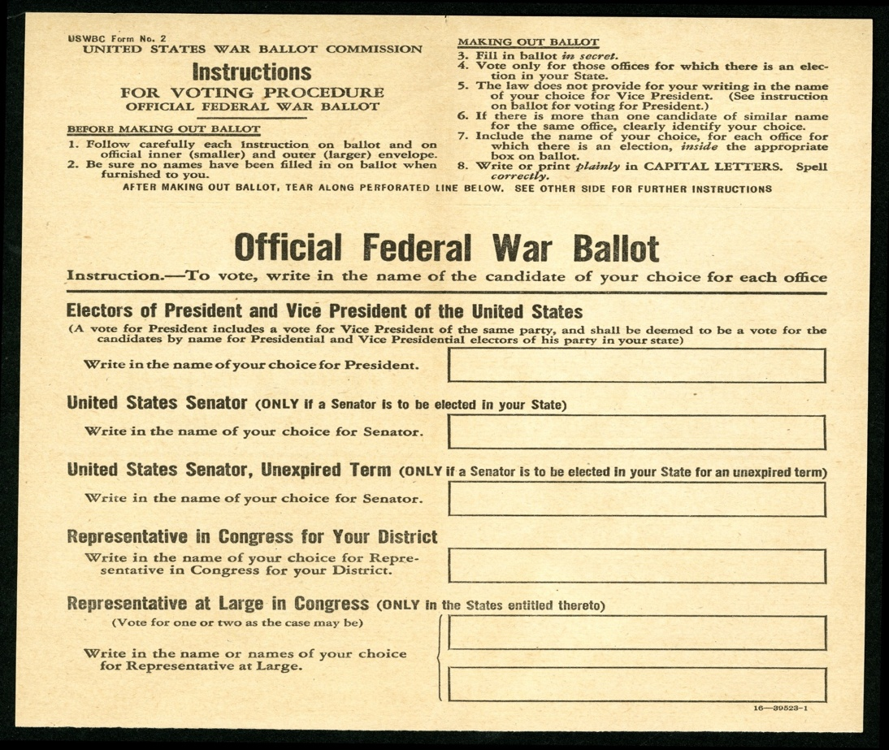
Absentee ballot sheet, 1944. Object 2024.2001.4, National Postal Museum.
Members of the military were allowed to vote absentee in the 1944 election thanks to an act of Congress. The War and Navy Departments supported this adoption of a universal ballot, where soldiers had to write in the names of the people they wished to vote for. This ballot was only good for federal, not local, elections. Not everyone in Congress supported the bill and, in the end, states were encouraged to amend their own absentee ballot procedures to allow soldiers to vote and not all states accepted this ballot.

Modern Expansion: No-Excuse Absentee Voting and Vote by Mail
In the early 2000s, absentee voting began to shift from a tool used primarily by people with specific needs, like military members, travelers, or the ill, to a more widely available option for all voters. A wave of electoral reform efforts pushed for “no-excuse absentee voting,” a policy that allowed any registered voter to request a mail-in ballot without needing to provide a reason. By eliminating eligibility requirements, states aimed to make voting more accessible, reduce congestion at polling places, and accommodate the demands of busy voters.
As momentum for accessibility grew, states like Oregon and Washington went even further by adopting universal vote-by-mail systems, mailing ballots to every registered voter automatically. These states reported increased turnout, reduced costs, and high levels of voter satisfaction. Still, not all states followed suit. While the majority embraced no-excuse absentee voting, a handful-maintained excuse-based systems, requiring voters to meet specific criteria.
Then came 2020—a year that would catapult absentee voting into the center of American political discourse.
With the outbreak of the COVID-19 pandemic, state and local election officials faced an unprecedented challenge: how to conduct safe, secure elections while minimizing the risk of in-person gatherings. In response, nearly every state expanded absentee voting access, whether by mailing ballots or applications to all voters, extending deadlines, or temporarily waiving excuse requirements. In that year’s general election, more than 65 million Americans, nearly half of all voters, cast their ballots by mail, the largest number in U.S. history.
But this dramatic expansion also ignited a national debate. Supporters argued that absentee voting was essential to protecting public health and preserving democratic participation during a crisis. They pointed to successful all-mail systems in states like Colorado and Oregon as evidence that vote-by-mail is secure, cost-effective, and reliable.
Critics, however, raised concerns about election integrity, claiming that large-scale mail voting could lead to fraud, delays, or mistrust in results, even though multiple studies and election audits have found no widespread evidence of fraud in absentee voting. These debates were amplified by political rhetoric, misinformation, and legal challenges that stretched well beyond the election itself.
Despite the controversy, absentee and vote-by-mail systems have become permanent features of the modern voting landscape. The experience of 2020 sparked lasting changes in some states, while others reverted to pre-pandemic restrictions.

- Inquiry Prompt: Why did absentee voting become such a prominent issue in 2020? What arguments were made for and against its expansion?​​
Voting by Mail: Civil War to Covid-19
(This link has resources from the Smithsonian’s exhibit on mail-in voting, including images of mail-in and absentee ballots from the Civil War to 2020).

Component 2: Absentee Voting & Vote by Mail: A Shared Purpose, Evolving Practices
Across the United States, voting without going to a polling place has become an essential way to ensure that more Americans can participate in elections, especially those who cannot vote in person on Election Day. Two systems support this: absentee voting and vote-by-mail elections.
At their core, both systems allow voters to cast their ballot through the mail, giving people more flexibility in how and when they vote. But the way these systems are structured, and who qualifies, can vary.
- Absentee voting has a longer history, dating back to the Civil War, when soldiers needed a way to vote while away from home. Over time, many states expanded absentee access, first requiring voters to provide a reason (like illness or military service) and later allowing “no-excuse” absentee voting, where any registered voter can request a mail ballot.
- In contrast, vote-by-mail elections are a newer development. In these states, every registered voter automatically receives a ballot by mail, no application required. Voters can return their ballot by mail, use secure drop boxes, or vote in person at designated locations. Vote-by-mail is now used as the primary method of voting in a small but growing number of states.
While both systems increase voting access, they differ in how ballots are distributed and who receives them automatically. As you explore the maps and policies in different states, think about how these systems reflect changing ideas about access, security, and convenience in American democracy.
In a growing number of U.S. states, elections are conducted using vote by mail, a system in which every eligible voter is automatically sent a ballot through the postal service — no request needed. These are also known as all-mail elections.
Even in vote-by-mail states, voters typically have multiple options for returning their ballot. They can:
- Mail it back using prepaid postage,
- Drop it off at a secure ballot drop box, or
- Return it directly to a local election office.
For those who prefer or need to vote in person, in-person voting options are still available in most vote-by-mail states, often through early voting centers or Election Day polling sites.

Voting-by-mail
Vote-by-mail elections are designed to expand voting access, especially for voters in rural areas, people with limited mobility, or those with demanding schedules. In many cases, this system has also been shown to:
- Increase voter turnout, and
- Lower election administration costs by reducing the need for large-scale polling operations.
When exploring the map, consider:
How might conducting elections primarily by mail impact voter access, security, and trust in different communities?

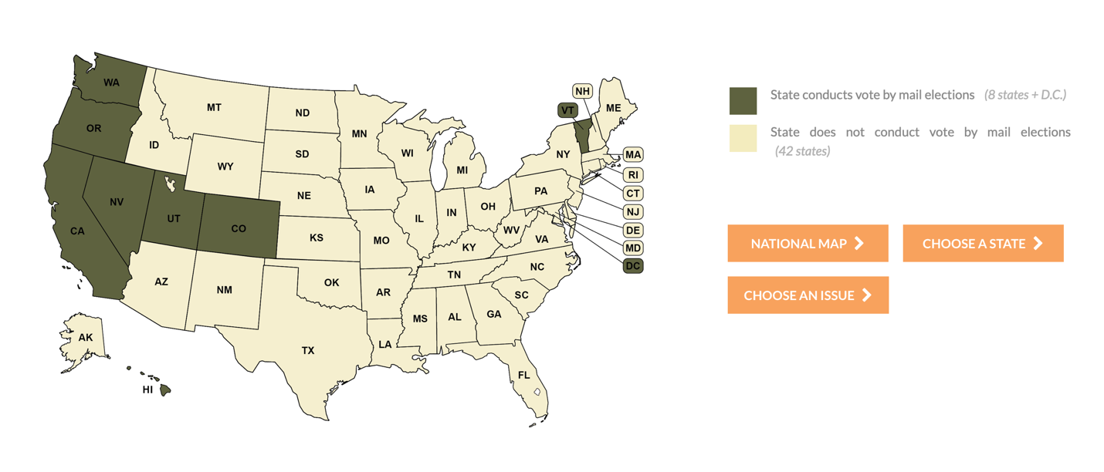
Movement Advancement Project. "Vote by Mail Elections." https://www.mapresearch.org/democracy-maps/mail_voting_states.

Absentee Voting
Absentee voting gives eligible voters the opportunity to cast a ballot without going to a traditional polling place, most often by using the mail. While all U.S. states allow absentee voting in some form, the rules about who qualifies and how ballots are distributed can vary significantly from state to state.
In some states, any registered voter can vote absentee without providing a reason, this is called "no-excuse absentee voting." A growing number of these states have expanded access even further by conducting "all-mail elections," where every eligible voter is automatically mailed a ballot, with no need to request one.
Other states require voters to meet specific criteria, such as having a medical emergency, being away from home on Election Day, or having a disability, in order to qualify for absentee voting. These are known as "excuse-required absentee states."
The map below provides a nationwide overview of these voting policies. It shows:
- Which states offer no-excuse absentee voting
- Which states conduct vote-by-mail elections
- And which states require a legal excuse to vote absentee
When exploring the map, consider:
How do differences in absentee voting laws affect voter access and participation across the country?
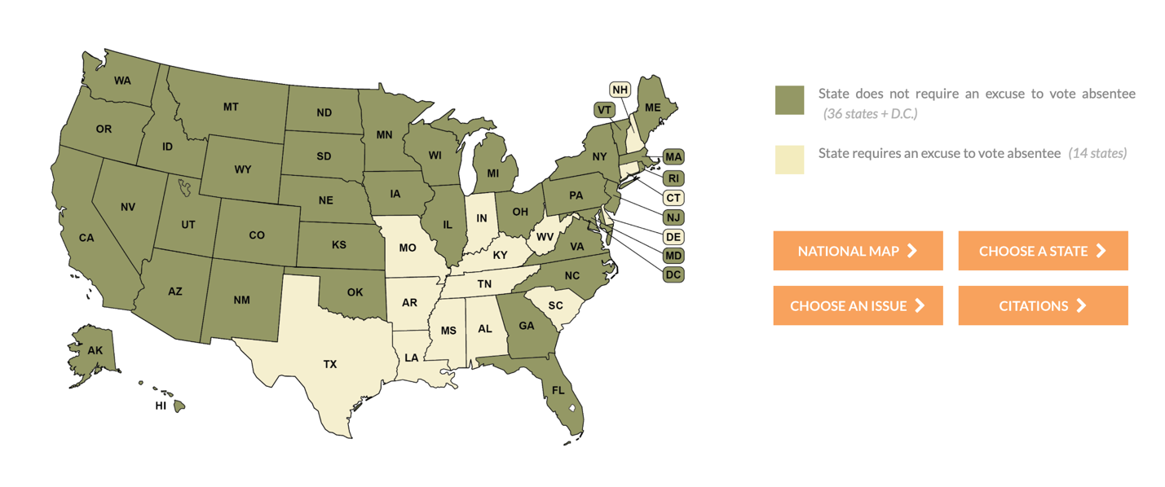
Movement Advancement Project. "Availability of No-Excuse Absentee Voting." https://www.mapresearch.org/democracy-maps/absentee_requirements.

Component 3: Absentee Voting & Vote by Mail in West Virginia

Absentee Voting in West Virginia
Absentee voting has long been a cornerstone of expanding democratic access in the United States, and West Virginia’s approach reflects both national trends and its own unique legal framework.
Like many states, West Virginia began formalizing absentee voting procedures in the 20th century, particularly in response to growing demands for access from military service members, students, and voters facing mobility challenges. The state’s system has steadily evolved, shaped by federal legislation such as the Uniformed and Overseas Citizens Absentee Voting Act (UOCAVA) and broader national movements to modernize the voting process.
However, unlike the growing number of states that offer “no-excuse absentee voting”—where any registered voter can request a mail-in ballot without providing a reason—West Virginia maintains an excuse-based model. This places it among a shrinking group of states that require voters to meet specific criteria to qualify for absentee voting.
How West Virginia’s Absentee Voting System Compares Nationally
- Excuse Required:
  - West Virginia requires voters to provide a qualifying reason to vote absentee, such as illness, travel, disability, or military service.
  - Most states now offer “no-excuse” absentee voting, allowing any registered voter to request a mail-in ballot without needing to justify their request.
- Ballots Are Not Mailed Automatically:
  - In West Virginia, voters must proactively apply for an absentee ballot.
  - A small but growing number of states conduct vote-by-mail elections, where all registered voters are automatically sent a ballot.
- Application Process:
  - West Virginia requires voters to submit a formal absentee ballot application each election cycle, including deadlines for receipt prior to Election Day.
  - This is similar to many other states, but differs from those that allow permanent absentee status or automatic ballot mailing.
- Return Requirements:
  - Absentee ballots in West Virginia must be postmarked by Election Day and received by the start of the canvass. Voters may also deliver them in person.
  - These return deadlines are fairly consistent with national standards, though some states allow ballots to count if received after Election Day, as long as they are postmarked in time.
- Electronic Voting Options:
  - West Virginia provides electronic absentee ballot delivery for certain groups, such as military and overseas voters (under UOCAVA) and voters with qualifying disabilities.
  - This is in line with federal requirements, though some states restrict electronic transmission more tightly or offer broader access.
- Temporary Pandemic Adjustments:
  - In 2020, West Virginia temporarily broadened absentee access in response to COVID-19, allowing voters to cite health concerns as a valid excuse.
  - While many states made similar adjustments, some made those changes permanent, West Virginia returned to its pre-pandemic rules.
While West Virginia follows many national norms, such as participating in the UOCAVA program and allowing early absentee requests, it continues to uphold the belief that absentee voting is an option for those with a demonstrable need, not a default method for all voters. This decision reflects a balancing act between access and oversight, rooted in the state’s legislative priorities and voting culture.
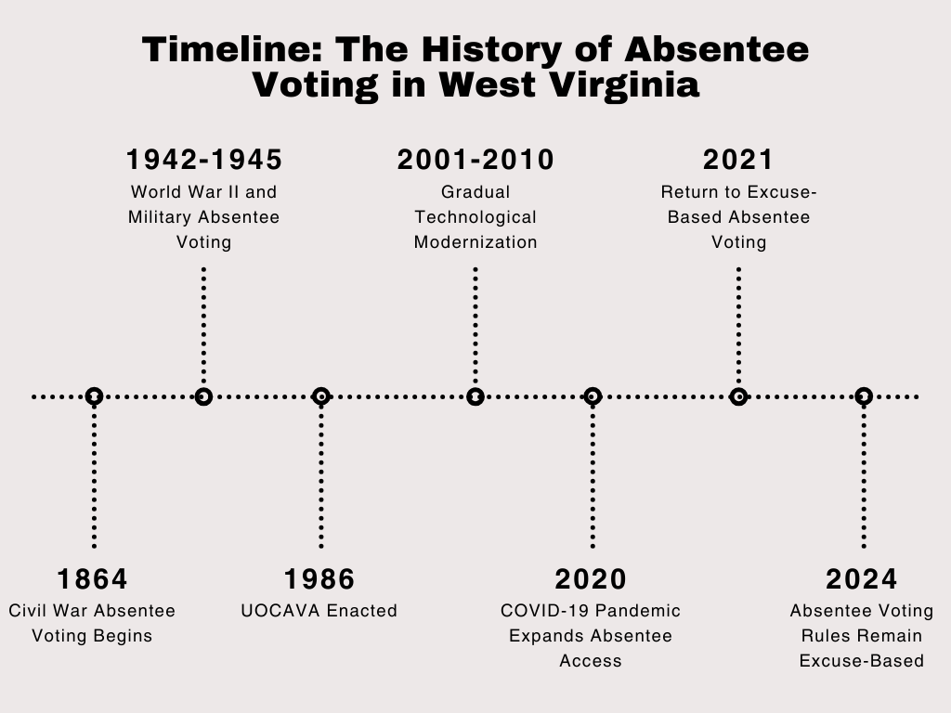Timeline: The History of Absentee Voting in West Virginia, Created by Hunter Neel

Why This Matters Today
In recent years, especially during the 2020 COVID-19 pandemic, many states temporarily broadened access to absentee voting in the name of public safety. West Virginia, like others, expanded its absentee criteria for the 2020 election, but returned to a stricter, excuse-required model afterward. This creates a dynamic landscape in which voter access, state law, and public trust continue to evolve.
Understanding how and why West Virginia differs from other states gives students insight into how voting rights are shaped not only by national values but by state-level choices.
Student Activity Prompt
Now that you have a broader perspective of absentee voting in West Virginia and have compared it to other states, turn to the primary source: West Virginia Code §3-3-1.
As you read, look for the answers to the following:
- What are the specific reasons a West Virginian may vote absentee?
- What rules govern how and when a ballot must be requested and returned?
- What groups receive special accommodations (like electronic voting)?
Highlight or annotate sections that surprise you and prepare to discuss how WV law reflects both local needs and national influences.
Comparison Reflection
After reading the statute, students will reflect on how West Virginia’s approach compares to other states. They may write a short paragraph or create a three-column chart comparing:
- West Virginia’s absentee voting rules
- A no-excuse absentee voting state (e.g., Pennsylvania)
- A vote-by-mail state (e.g., Oregon)
Civic Literacy Challenge: Explain the Law
Students will imagine they are creating a flyer to help inform West Virginia voters about how absentee voting works in the state. The goal is to clearly explain:
- Who qualifies
- How to apply
- Key deadlines
This exercise challenges students to translate complex legal language into accessible civic information.
Discussion Prompts:
- Why do you think West Virginia has kept its excuse requirement for absentee voting?
- What are the pros and cons of requiring voters to provide a reason?
- How might West Virginia’s rural geography, aging population, or political climate influence its voting laws?
Note:
To extend this lesson with a hands-on component, consider incorporating the Absentee Voting Simulation Activity. This classroom exercise uses the official West Virginia absentee ballot application form and guides students through the process of completing and submitting a simulated application. Students experience firsthand the challenges and requirements of voting by mail in West Virginia, with some applications approved and others rejected to reflect real-world scenarios. The simulation is an excellent way to deepen understanding of access, accuracy, and voter eligibility.

Component Four: Mail-In Voting in West Virginia and Around the World
Keeping in mind that election systems reflect national values, geographic realities, and evolving technologies, this lesson will explore the development of mail-in voting in West Virginia and the United States and compare it to international models in Switzerland, Estonia, and Albania. Students will analyze how different countries approach voting by mail, what obstacles they face, and how those challenges are shaped by infrastructure, civic trust, and institutional support.
Note: The Constitution does not guarantee a right to vote by mail. What, then, are the legal and cultural factors that shape how different societies view mail-in voting? In the U.S., absentee voting policy is largely left to the states. How does this decentralization compare with more centralized systems abroad?

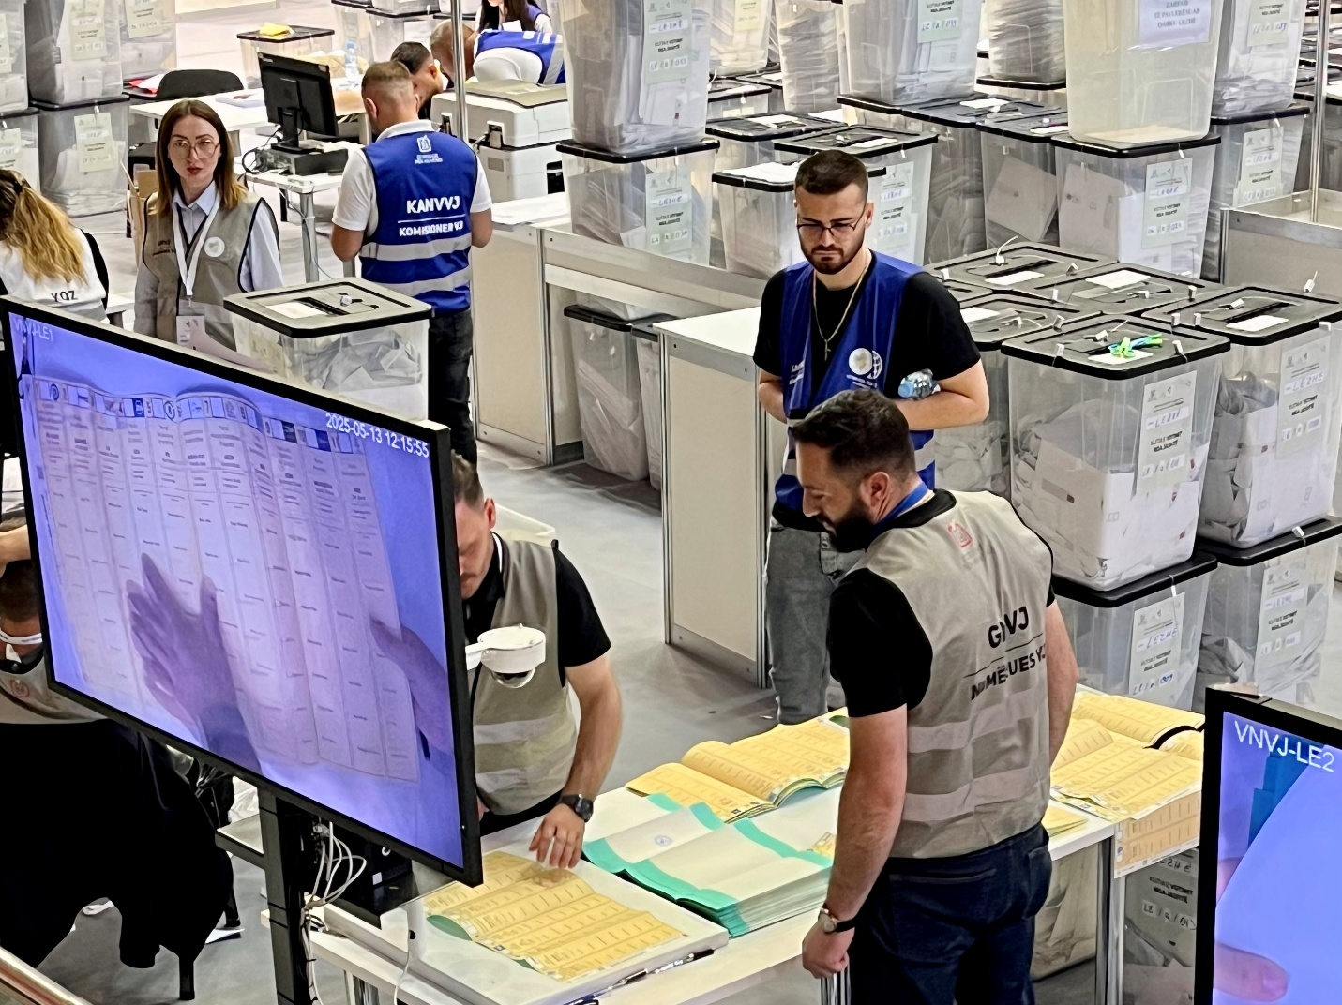Photo from the 2025 Albanian mail-in voting counting system. Photo courtesy of Erik Herron.

Mail Voting in West Virginia and the United States
In West Virginia, absentee voting is available only to those who meet specific eligibility criteria. Voters must request an absentee ballot and provide a qualifying excuse, such as illness, travel, military service, or disability. Ballots are mailed out 46 days before the election, and must be postmarked by Election Day and received by the start of the canvass to be counted. While West Virginia piloted blockchain voting for UOCAVA voters in 2018, most voters must adhere to a traditional, excuse-based absentee process.
Nationally, absentee voting practices vary. Some states offer no-excuse absentee voting, while others, like West Virginia, continue to require a valid excuse. A small but growing number of states have adopted vote-by-mail systems, where every registered voter is automatically sent a ballot. The 2020 COVID-19 pandemic prompted an unprecedented expansion of vote-by-mail access nationwide, though some of those temporary measures have since been rolled back.

International Comparison: Switzerland, Estonia, and Albania
Switzerland has one of the most robust vote-by-mail systems in the world. Since 1978, Swiss cantons have progressively adopted postal voting. Today, over 90% of Swiss voters return their ballots by mail. Voters receive ballots and informational materials several weeks before an election and may return ballots by mail or deposit them in local boxes. Elections in Switzerland emphasize transparency and community engagement, with ballots typically counted manually at the local level.
Estonia has taken a different approach by pioneering digital voting. Since 2005, Estonia has offered online voting ("i-voting") to citizens with a secure national ID. Voters can cast ballots online during an early voting period and even change their vote by voting again. Over half of Estonian voters now use this method. While concerns about cybersecurity remain, Estonia has prioritized digital literacy and citizen trust in government institutions to support the system's success.
Albania, in contrast, is a newer entrant to vote-by-mail systems. In the 2025 parliamentary elections, Albania allowed citizens living abroad to vote by mail for the first time. However, problems quickly emerged. Ballot delivery delays, particularly to voters in Greece, led the Central Election Commission (CEC) to demand an urgent report from the mail service provider. These logistical challenges highlight the importance of infrastructure, clear timelines, and coordination between agencies when implementing mail voting for diaspora populations.
Inquiry Prompts:
- How does West Virginia's approach to absentee voting reflect its values around access and oversight?
- What can West Virginia (and the U.S. more broadly) learn from countries like Switzerland and Estonia?
- What challenges did Albania face, and how might they be avoided in future elections?
- What role do civic trust, infrastructure, and digital access play in shaping the success or failure of mail-in voting?
Case Study Analysis Exercise: Students will work in groups to compare West Virginia with one international example:
- Create a profile of your assigned country or state.
- Identify who can vote by mail, how ballots are distributed and returned, and what challenges exist.
- Present your findings to the class and make a recommendation: What features of this system (if any) should be adopted or avoided in West Virginia?
Extension Activity: Using what they've learned from these comparisons, students will design a "model" mail-in voting system. They will need to consider security, accessibility, logistics, and cost, and write a short justification for how their system balances those competing priorities.
Absentee Voting Simulation Activity Packet
Activity Overview
This simulation activity is designed to give students a realistic, hands-on experience of applying for an absentee ballot in the state of West Virginia. By engaging with the actual West Virginia absentee ballot application and completing it under simulated conditions, students will better understand the process, requirements, and challenges associated with mail-in voting. The activity also provides insight into how administrative errors and eligibility limitations can impact access to the ballot. This lesson supports student learning around voter engagement, election policy, and civic responsibility.
Teacher Instructions
Before beginning the simulation, prepare a set of fictional voter profiles. Each student should receive a different scenario that includes relevant personal details, a mailing address, and a stated reason for requesting an absentee ballot. Some profiles should meet the eligibility requirements in West Virginia, while others should not.
Link to the current WV Absentee Voting Application: https://sos.wv.gov/FormSearch/Elections/Voter/Absentee%20Ballot%20Application.pdf
Absentee Voting Simulation Activity Packet
Ensure that each profile includes subtle issues students must catch, such as mismatched mailing addresses or incorrect excuse types. This will help simulate common reasons for rejection.
After collecting the applications, review each one for accuracy and completeness using the checklist provided below. Approve or reject the applications accordingly. Provide brief written feedback for each student, simulating a response from a county clerk's office. You may choose to read a few applications aloud (with names anonymized) to highlight strong examples and common mistakes.
Following the simulation, guide students through a discussion on what the experience was like and how it changed or deepened their understanding of voting access and administration.
Teacher Evaluation Checklist
Use the following questions to evaluate each student's completed absentee ballot application:
- Has the student filled in all required fields legibly and accurately?
- Has the student selected a valid excuse under West Virginia law?
- Is the mailing address appropriate and consistent with the reason for the request? - Is the application signed and dated?
- Are there any inconsistencies or missing information that would result in rejection?
Mark the application as approved or rejected.
Discussion and Reflection
After the simulation, use the following questions to prompt a class discussion or individual reflection:
1. What did you learn about the process of applying for an absentee ballot?
2. If your application was rejected, what caused the issue? Was it a small mistake or a larger eligibility problem?
3. What does this experience reveal about barriers voters may face in real life?
4. How might the system be improved to reduce confusion or prevent unnecessary rejections?
5. Do you think West Virginia's absentee voting rules are fair? Why or why not?
Student Instructions
In this activity, you will take on the role of a voter applying for an absentee ballot in West Virginia. Your teacher will give you a fictional profile describing your name, address, and reason for needing to vote absentee.
Using this information, you will fill out a real West Virginia absentee ballot application form. Be sure to complete each section of the form carefully, just as you would if you were submitting it to your local election office. Include the correct mailing address, check the correct box for your reason, and make sure the form is signed and dated.
Once you submit your form to your teacher, it will be reviewed and either approved or rejected based on the information you provided. You will receive written feedback about your application's status and the reasoning behind the decision.
After all forms have been processed, we will hold a class discussion about what this experience revealed about access, accuracy, and barriers to voting by mail.

Contents
No table of contents entries found.

This project is presented with financial assistance from the West Virginia Humanities Council, a state affiliate of the National Endowment for the Humanities. Any views, findings, conclusions or recommendations do not necessarily represent those of the West Virginia Humanities Council or the National Endowment for the Humanities. 

Glossary of Election Terms from the U.S. Election Assistance Commission
Gerrymandering Explained | Brennan Center for Justice
9780190258658_Print_for authors.pdf
Poll taxes in the United States.Poll tax | EBSCO Research Starters.
Harris, Duchess, and Kari A. Cornell. The Right to Vote. Edited by Marie Pearson. Minneapolis, Minnesota: Essential Library, an imprint of Abdo Publishing, 2018. http://search.ebscohost.com/login.aspx?direct=true&scope=site&db=nlebk&db=nlabk&AN=1612987.
The Yale Law Journal - Forum: Ending Citizenship for Service in the Forever Wars.
100 years of Indian Citizenship Act of 1924 - Choctaw Nation of Oklahoma. More than 12,000 Native Americans served during WWI, including those not fully recognized as US citizens.
Native Americans in WWI: Courage and Sacrifice | National WWI Museum and Memorial.
Voter registration | MIT Election Lab.
Alexander Keyssar, “Voter Registration: A Very Short History,” Voter-Registration-A-Very-Short-History.pdf
John S. Wise, The End of an Era (New York, Houghton, Mifflin and Company, 1902), 55-56. The end of an era : Wise, John S. (John Sergeant), 1846-1913 : Free Download, Borrow, and Streaming : Internet Archive
Duchess Harris. 2018. Right to Vote. Minneapolis, Minnesota: Essential Library. https://research.ebsco.com/linkprocessor/plink?id=84932619-13f9-3bac-942c-03aea7c5003b. 67.
R46406.8.pdf
Automatic Voter Registration, a Summary | Brennan Center for Justice
Duchess Harris. 2018. Right to Vote. Minneapolis, Minnesota: Essential Library. https://research.ebsco.com/linkprocessor/plink?id=84932619-13f9-3bac-942c-03aea7c5003b. 73.
Voter ID Laws by State 2025. Editorial note: On May 1, 2025, West Virginia Governor Patrick Morrisey signed House Bill 3016, which now requires a photo id for voter registration and voting in West Virginia. Voters without acceptable ID can cast a provisional ballot until their identity is verified. Governor Patrick Morrisey Signs Voter ID Bill Into Law | WV Office of the Governor Patrick Morrisey
R46406.8.pdf
File:Same-day voter registration in the United States by states.svg - Wikimedia Commons
Erik S.Herron, Robert J. Pekkanen, and Matthew S. Shugart, eds., The Oxford Handbook of Electoral Systems (New York: Oxford University Press, 2018), 478.
Voter Registration —
The other nations who do not take a proactive role in registering voters are the Bahamas, Belize, Burundi, and Mexico, Jennifer S. Rosenberg with Margaret Chen, Expanding Democracy: Voter Registration Around the World (New York: Brennan Center for Justice at NYU School of Law, 2009), 9. Report_Expanding Democracy- Voter-Registration-Around-World.pdf.
Jennifer S. Rosenberg with Margaret Chen, Expanding Democracy: Voter Registration Around the World (New York: Brennan Center for Justice at NYU School of Law, 2009), Report_Expanding Democracy- Voter-Registration-Around-World.pdf.

